AWS Template – AWS-GSLB Test Cases

Table of Contents

Resource Creation 2

Resource Stack 2

Subnets 2

Virtual Network 3

Public Ips 4

Security groups 10

vThunder Instances 16

Server Instances 18

vThunder Networking Configuration on AWS 20

vThunder-1[controller side] 20

Management Interface 20

Data Interface (Client Side) 21

Data Interface (Server Side) 22

vThunder-2[site 2] 22

Management Interface 22

Data Interface (Client Side) 23

Data Interface (Server Side) 25

vThunder-3[SITE 2] 26

Management Interface 26

Data Interface (Client Side) 26

Data Interface (Server Side) 27

vThunder IP Configuration 29

GSLB Group 29

GSLB Protocol 30

Sites and Controller Complete Configurations: 32

DNS lookup 39

# Resource Creation

## Resource Stack

Resources are created in 2 GSLB regions.

Region 1

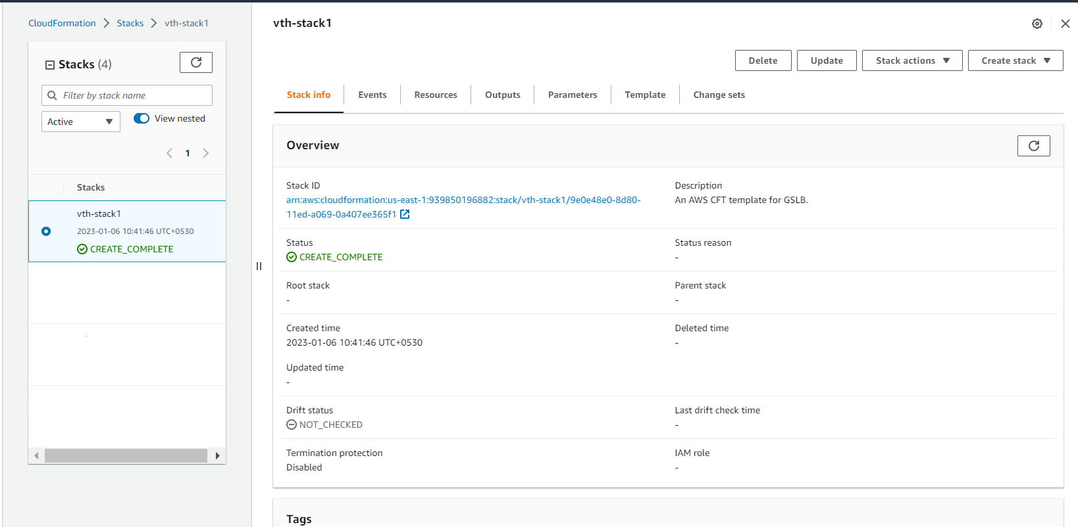

Region 2

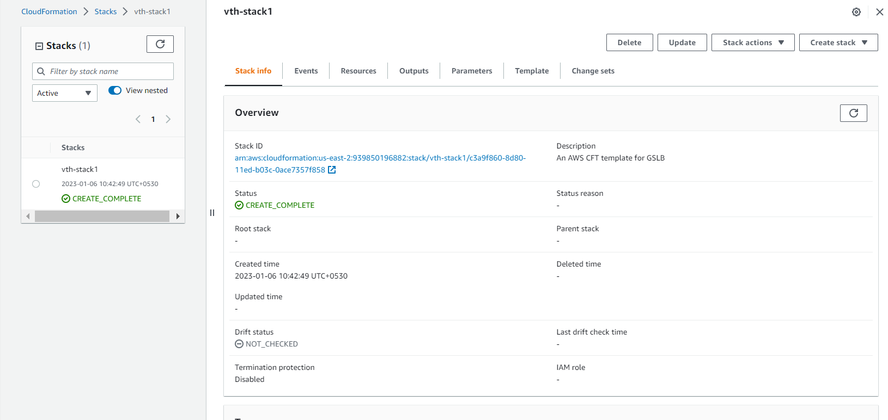

## Subnets

* Expected Outcome: 3 subnets should get created in each GSLB region.
* Actual Outcome: 3 subnets are created in each GSLB region.

Region 1

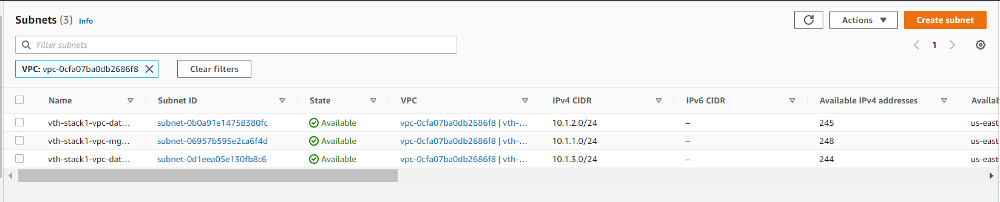

Region 2

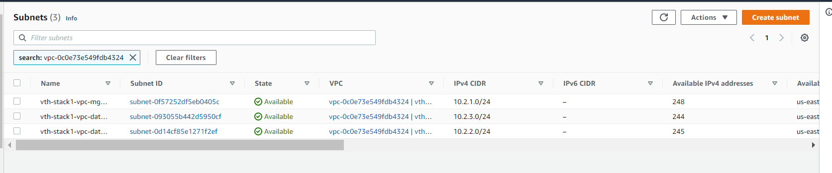

## Virtual Network

* Expected Outcome: 1 virtual network should get created in each GSLB region.
* Actual Outcome: 1 virtual network is created name “vth-stack-1-vth-vpc”.

Region 1

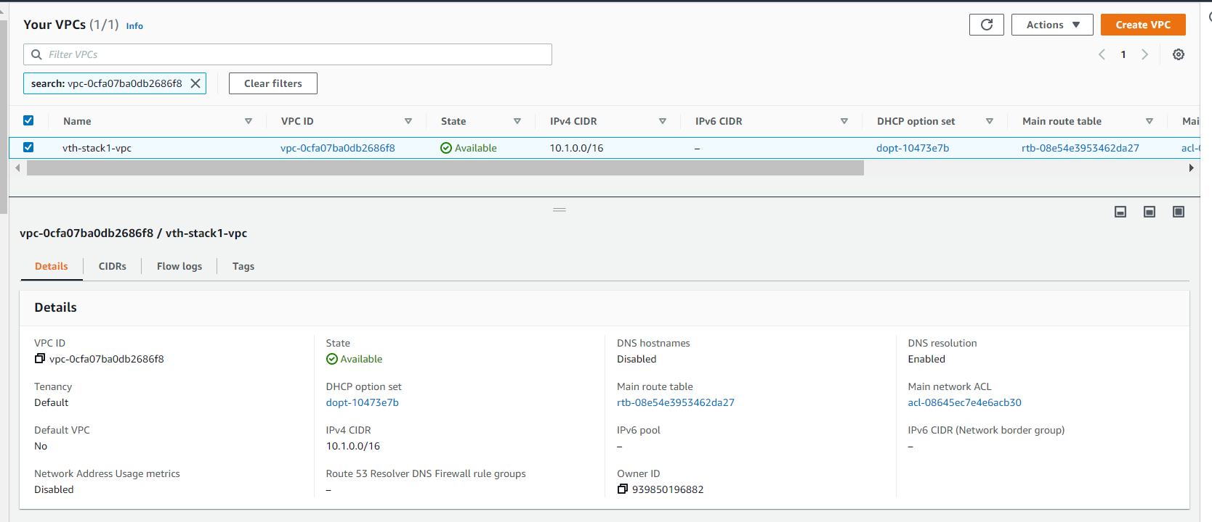

Region 2

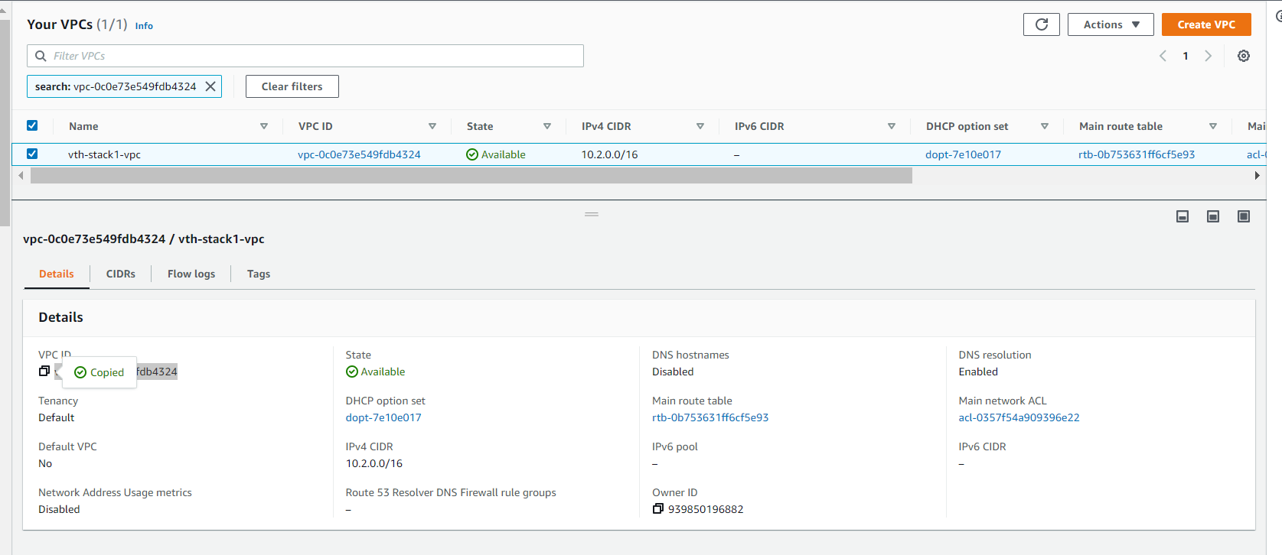

## Public Ips

* Expected Outcome: 6 public EIP get created in each GSLB region and assigned to generated instances.
* Actual Outcome: 6 public EIP get created in each GSLB region and assigned to generated instances

Region 1

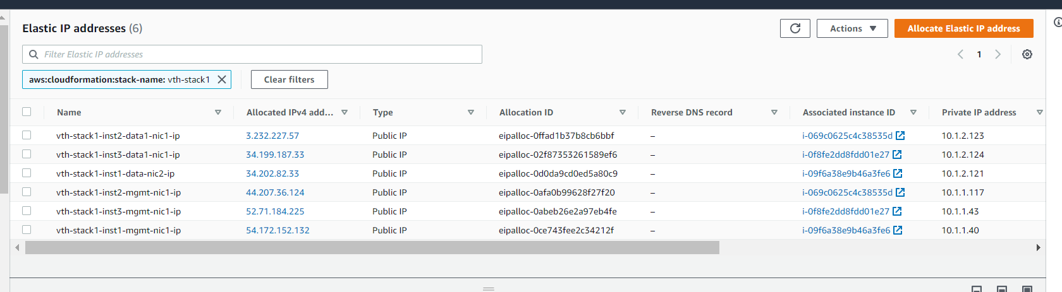

Region 2

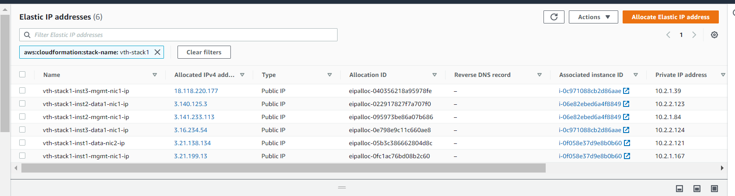

vth-stack-1-vth-inst1-mgmt-nic1*-*ip is assigned to instance 1 management interface.

Region 1

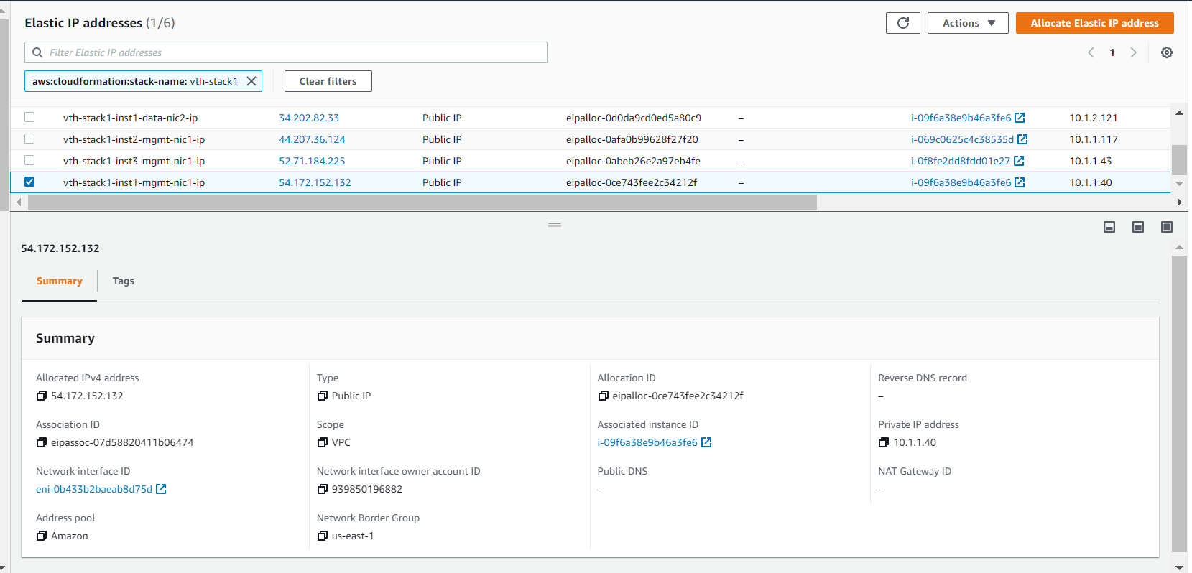

Region 2

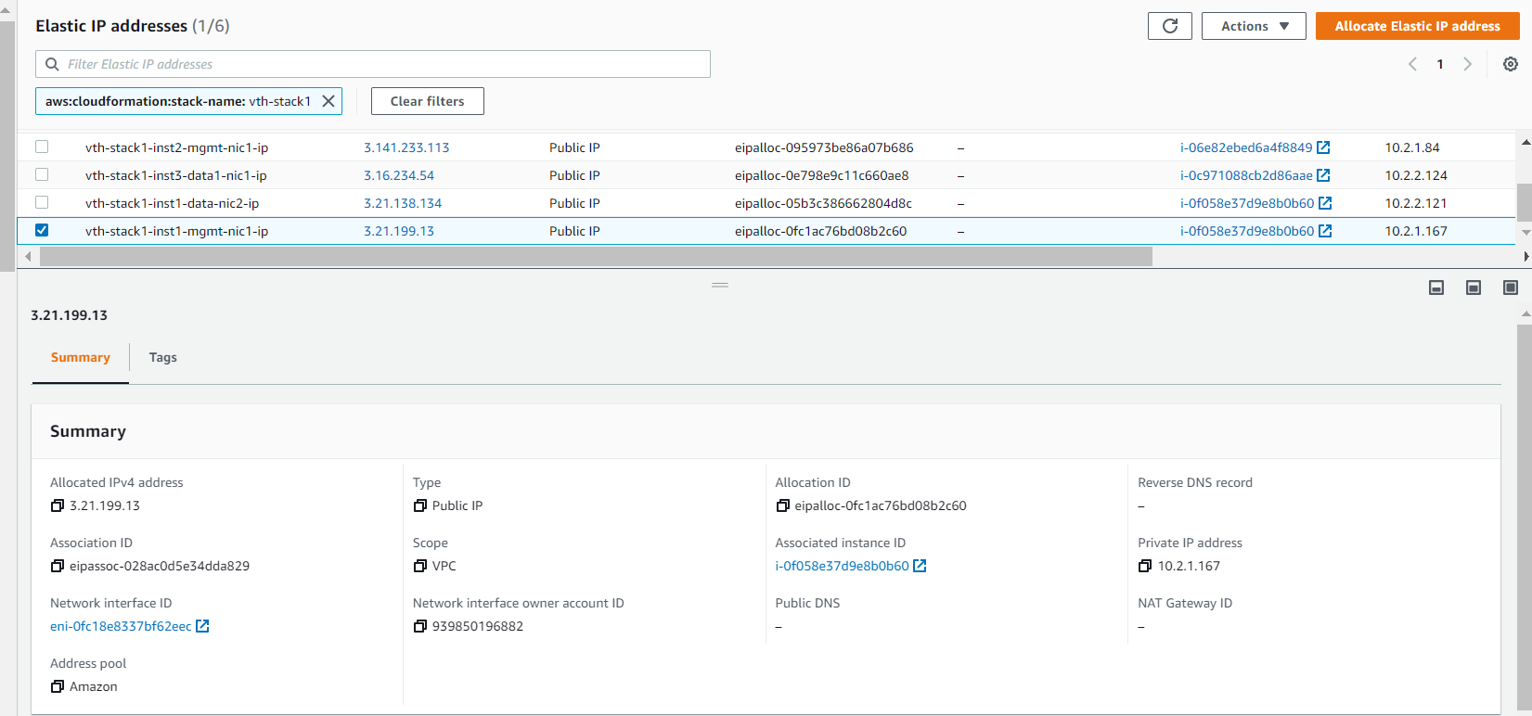

vth-stack1-vth-inst1-data-nic1*-*ip is assigned to instance 1 data interface.

Region 1

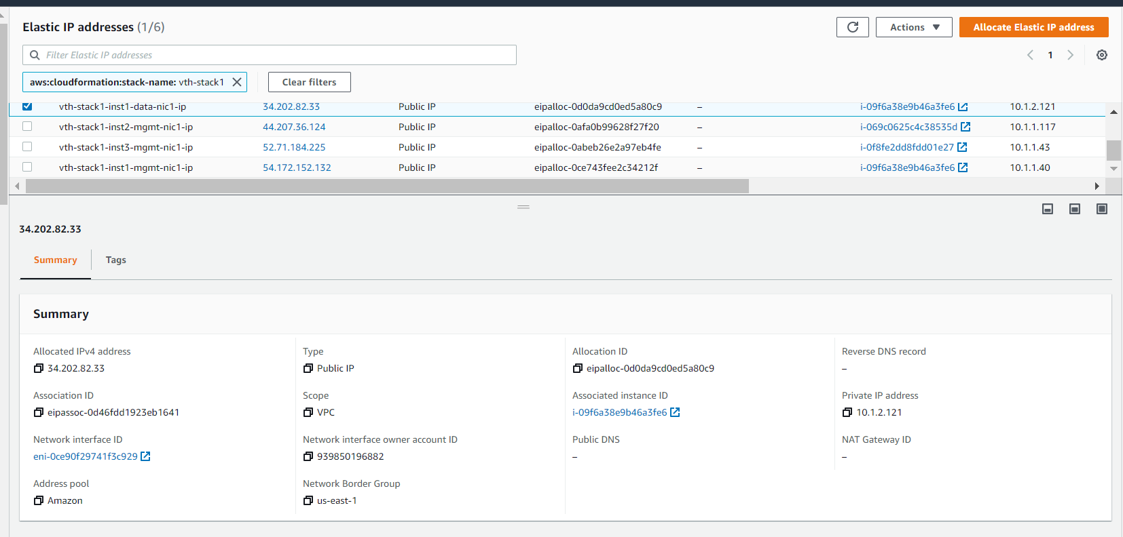

Region 2

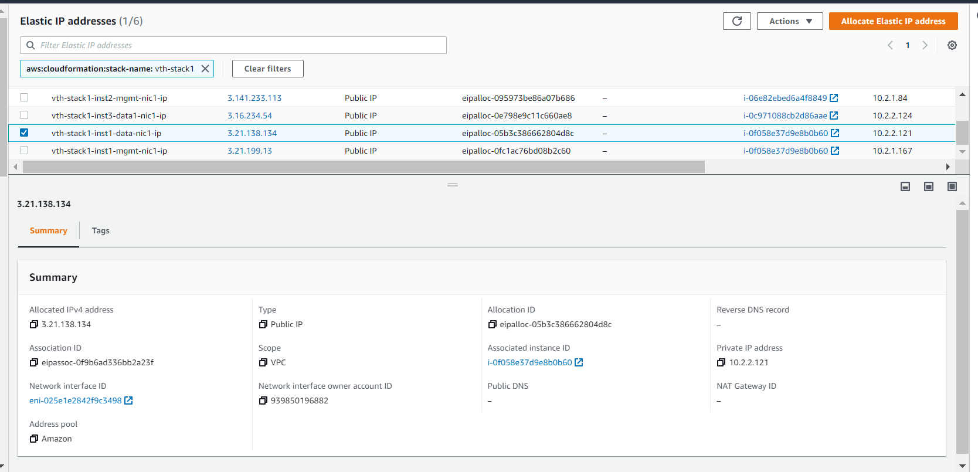

vth-stack-1-vth-inst2-mgmt-nic1-ip is assigned to instance 2 management interface

Region 1

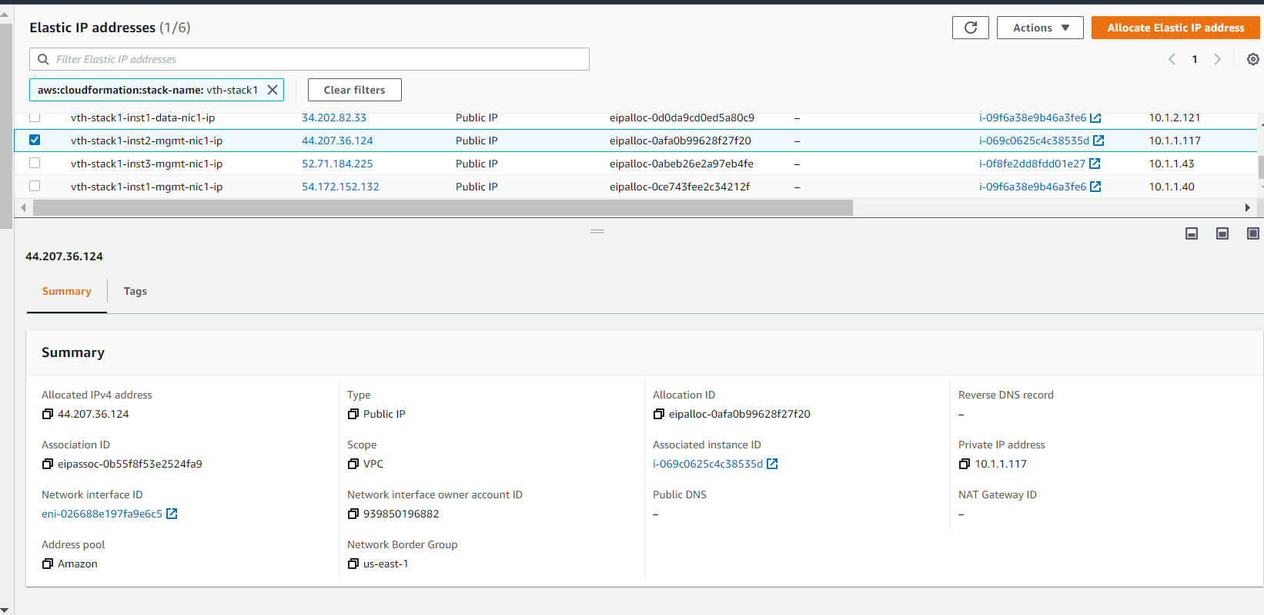

Region 2

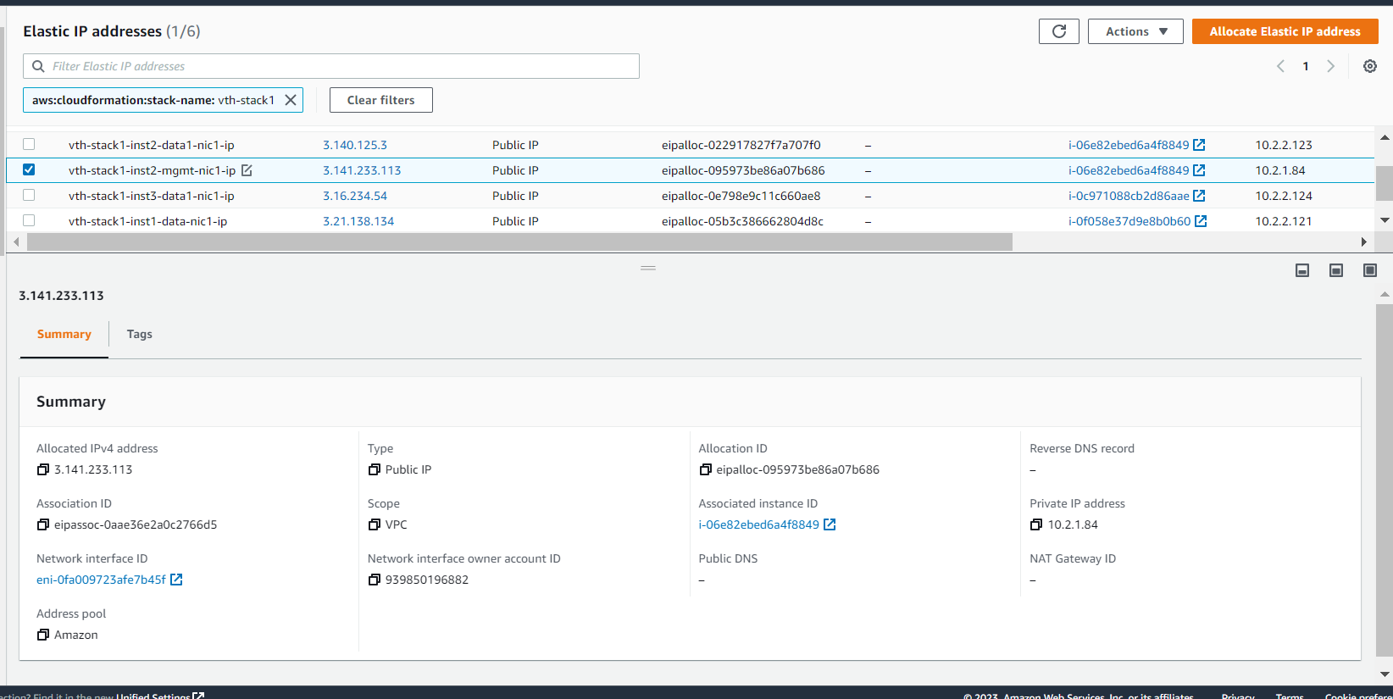

vth-stack-1-vth-inst2-data-nic1-ip is assigned to instance 2 data interface

Region 1

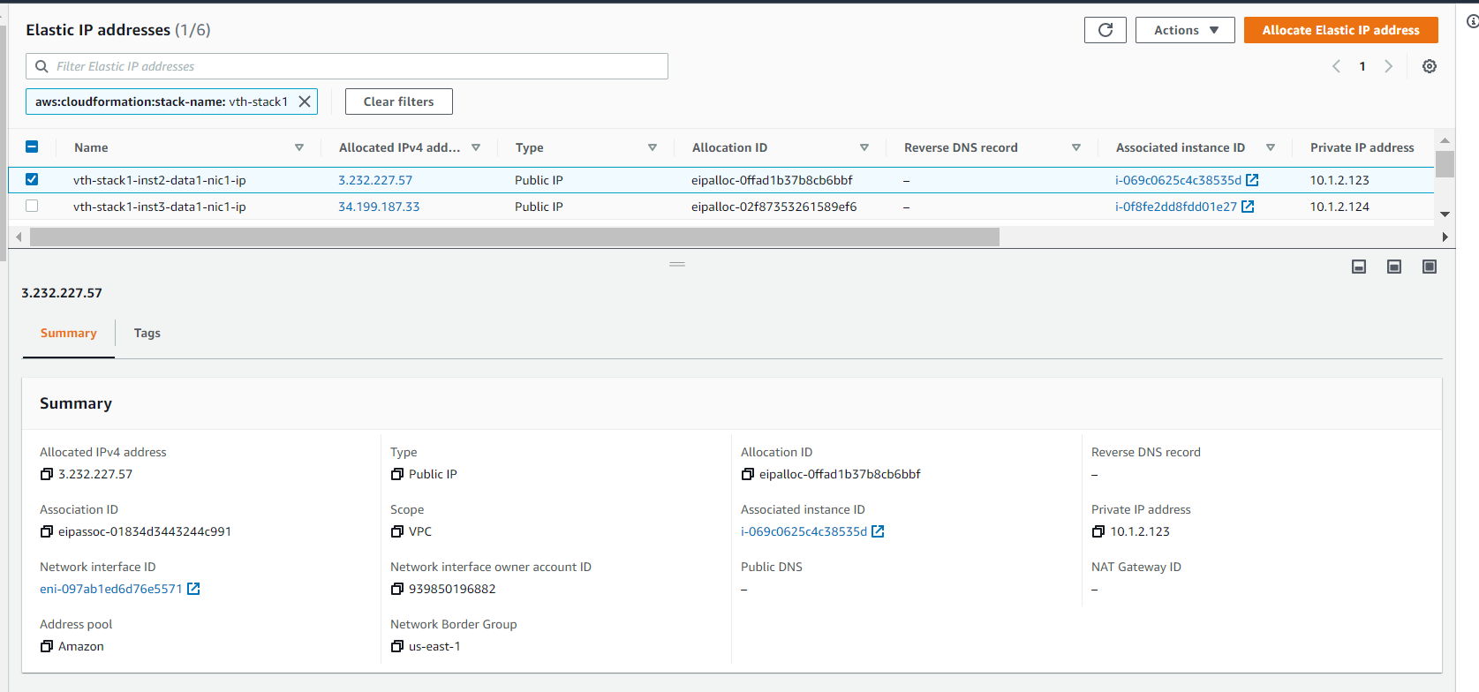

Region 2

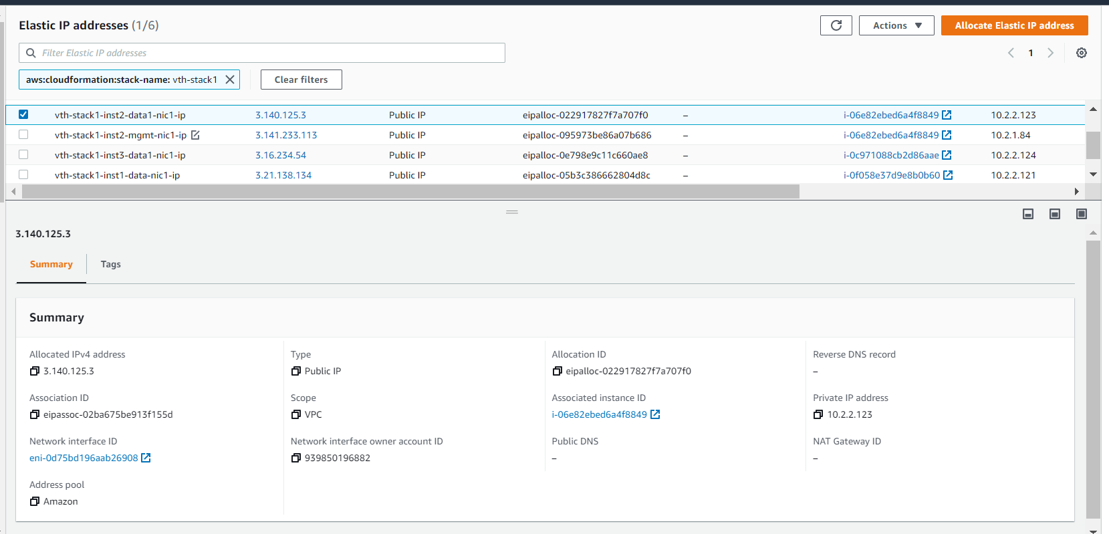

vth-stack-1-vth-inst3-data-nic1*-ip* is assigned to instance 3 data interface.

Region 1

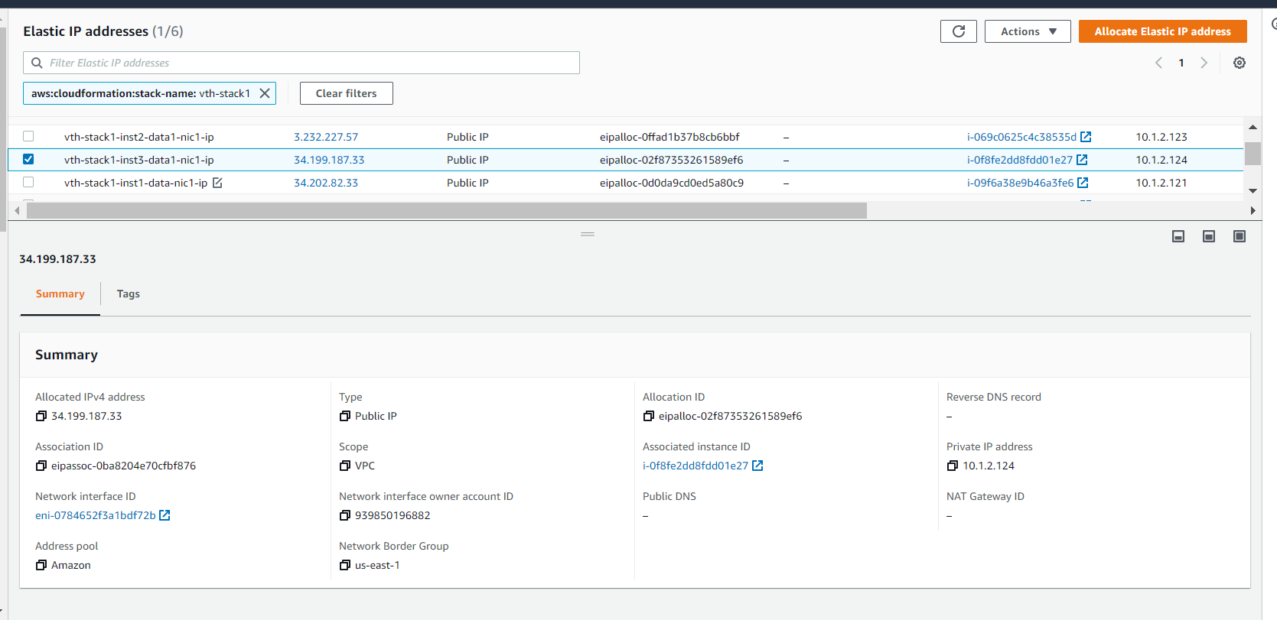

Region 2

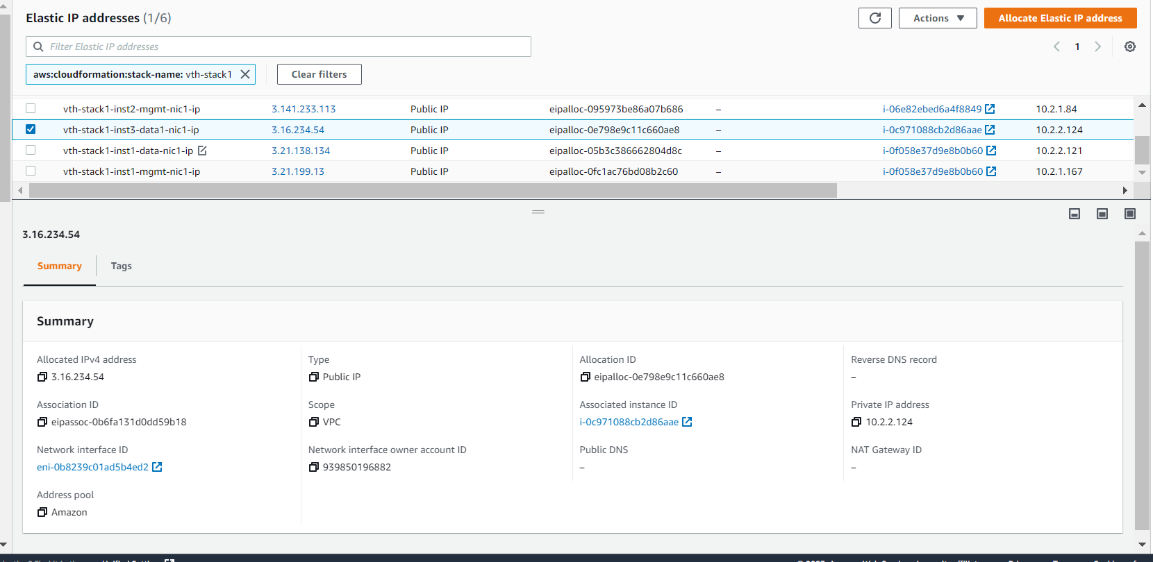

vth-stack-1-vth-inst3-data-nic1-ip is assigned to instance 3 data interface

Region 1

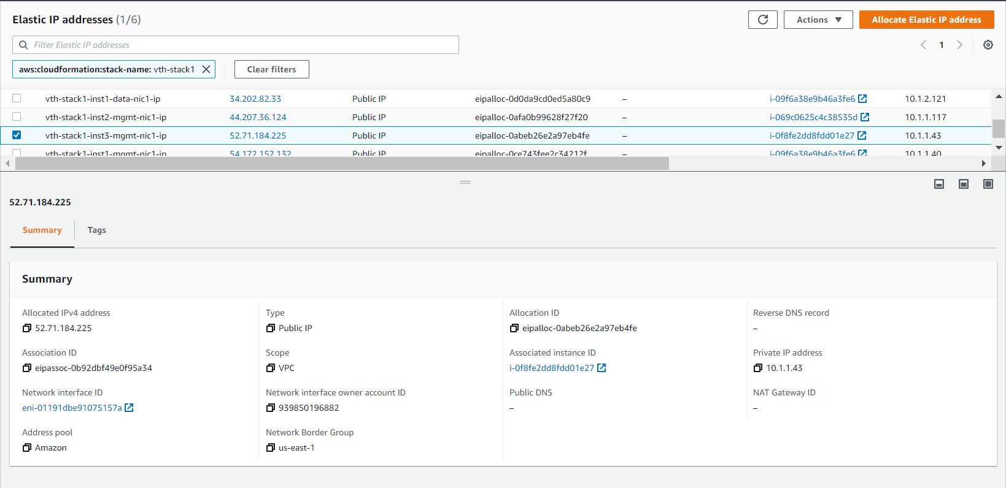

Region 2

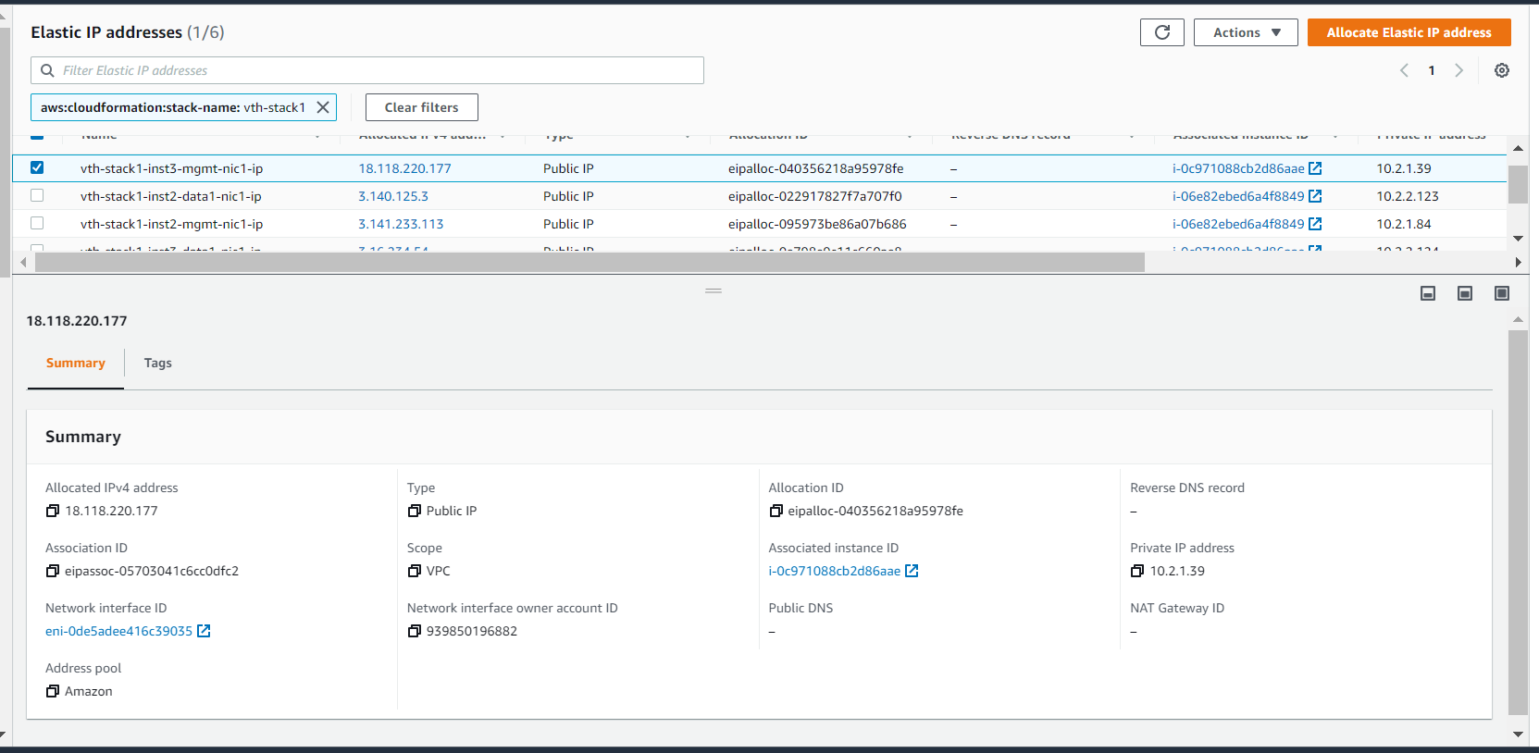

## Security groups

* Expected Outcome: 2 security group should get created in each GSLB region and must have inbound rules.
* Actual Outcome: 2 security group is created in each GSLB region and attached to VMs and there are some inbound security rules created.

Region 1

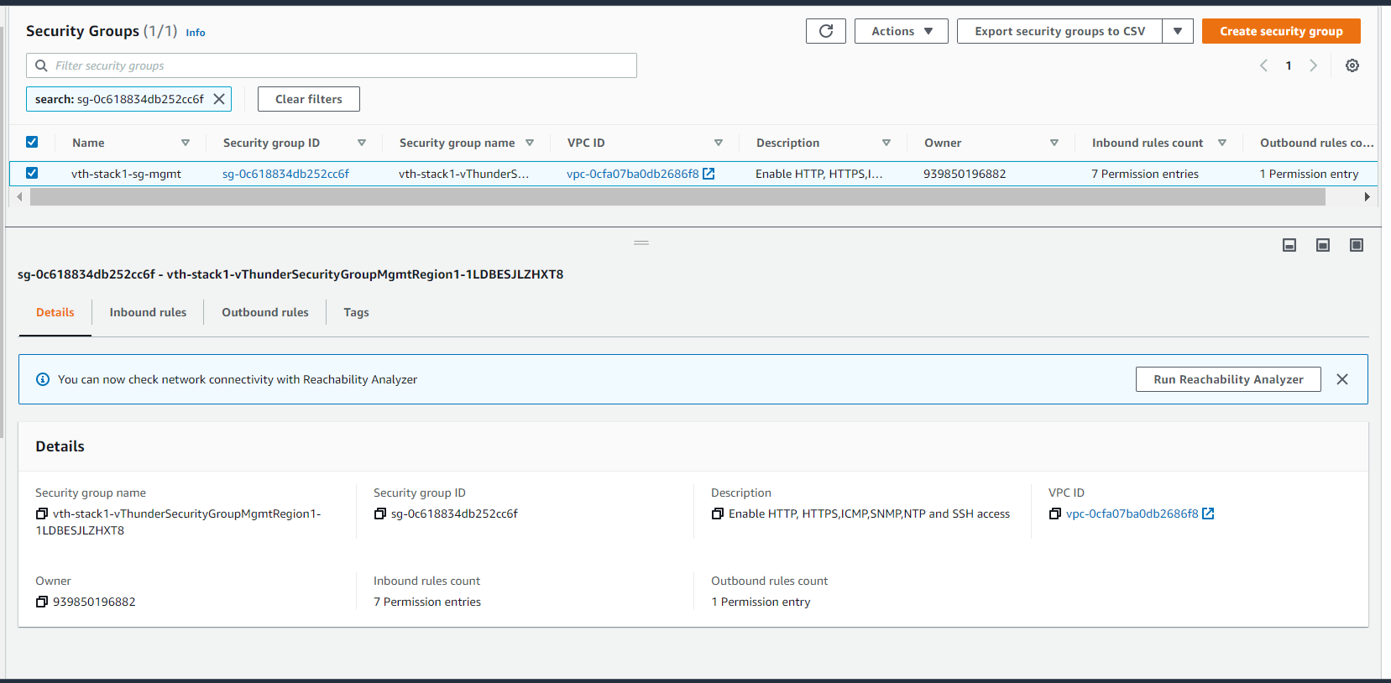

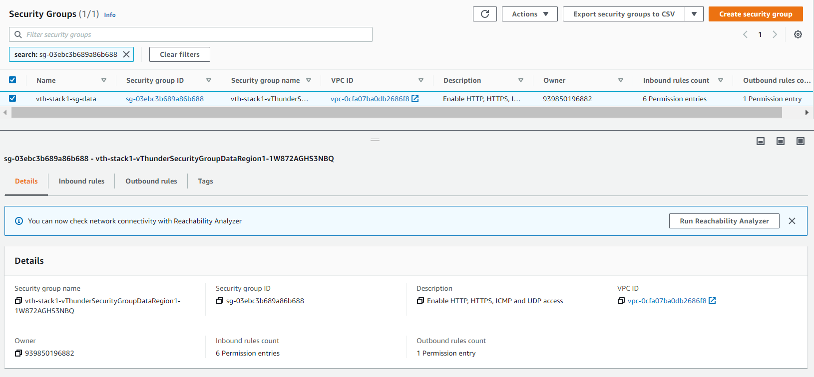

Region 2

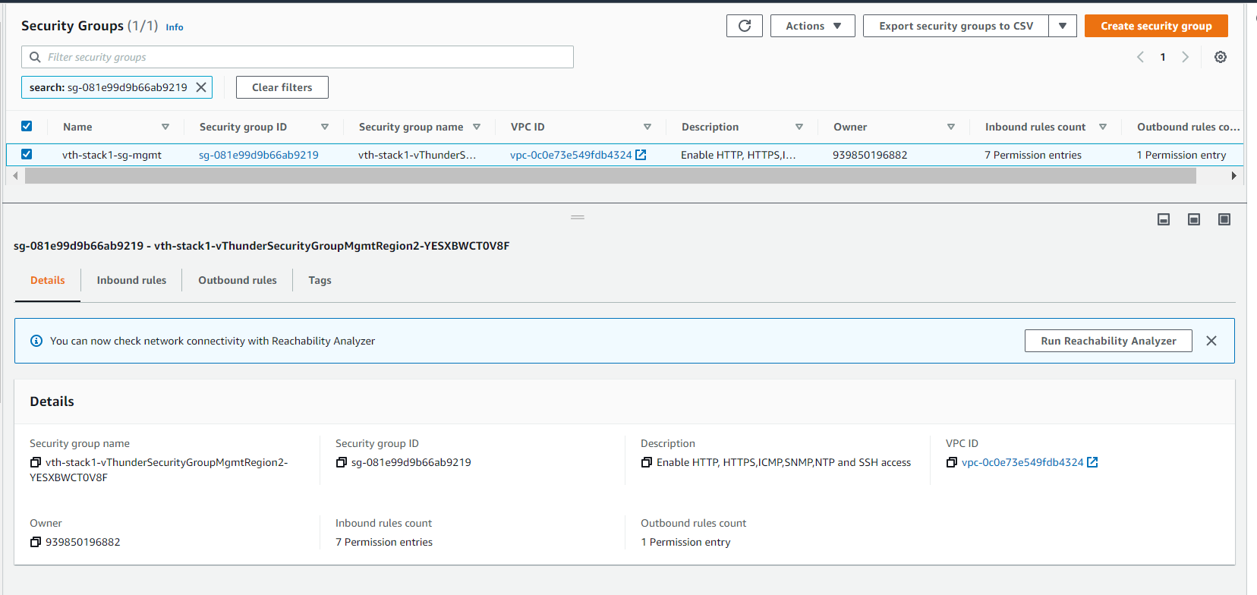

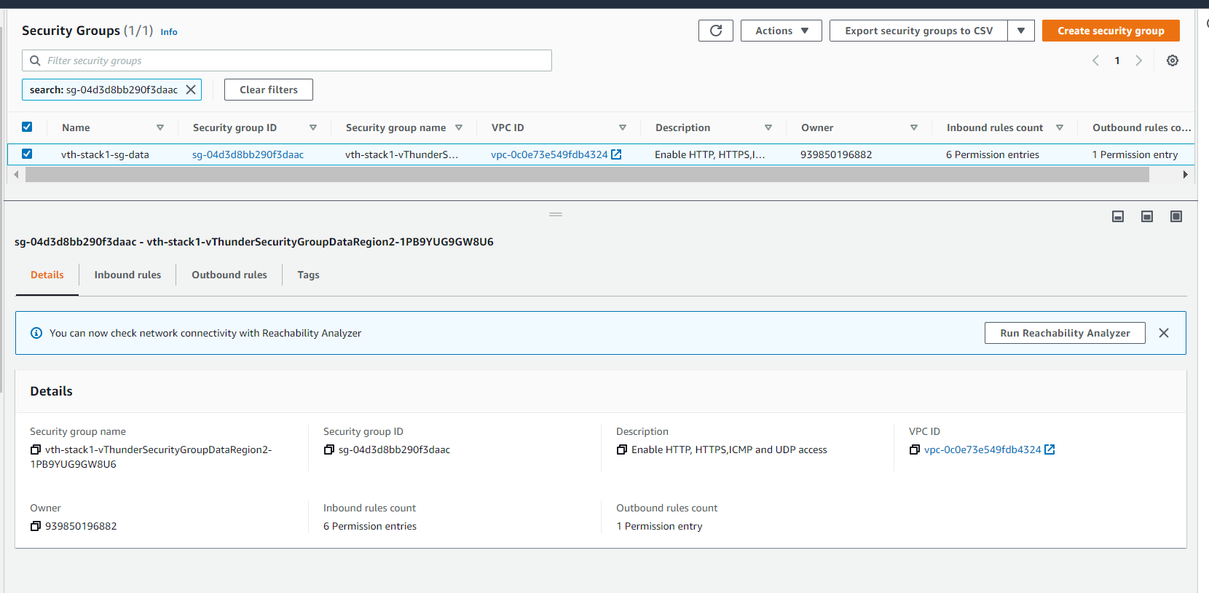

Network Security Group Inbound rules.

Region 1

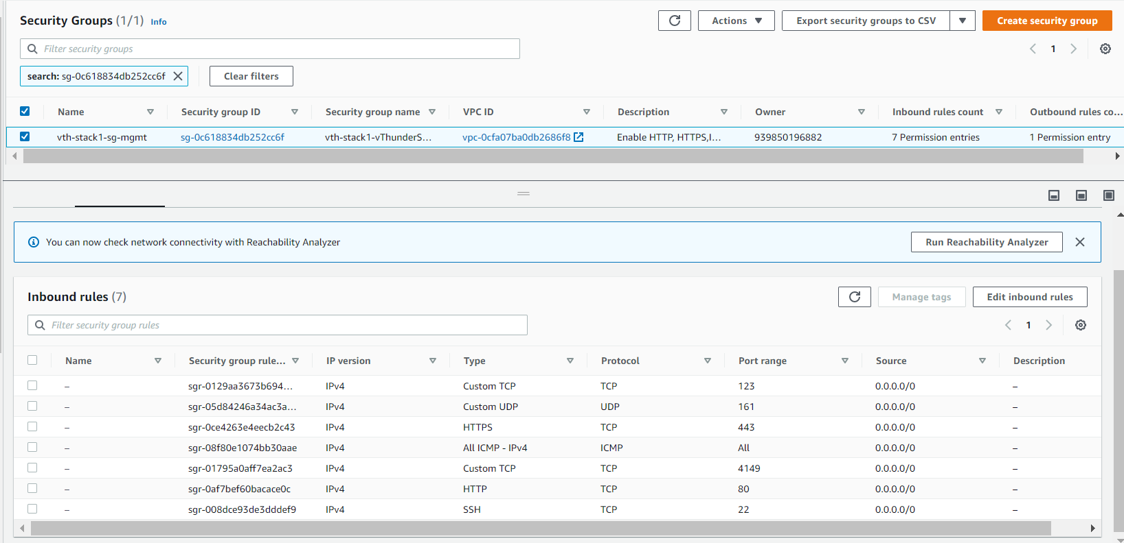

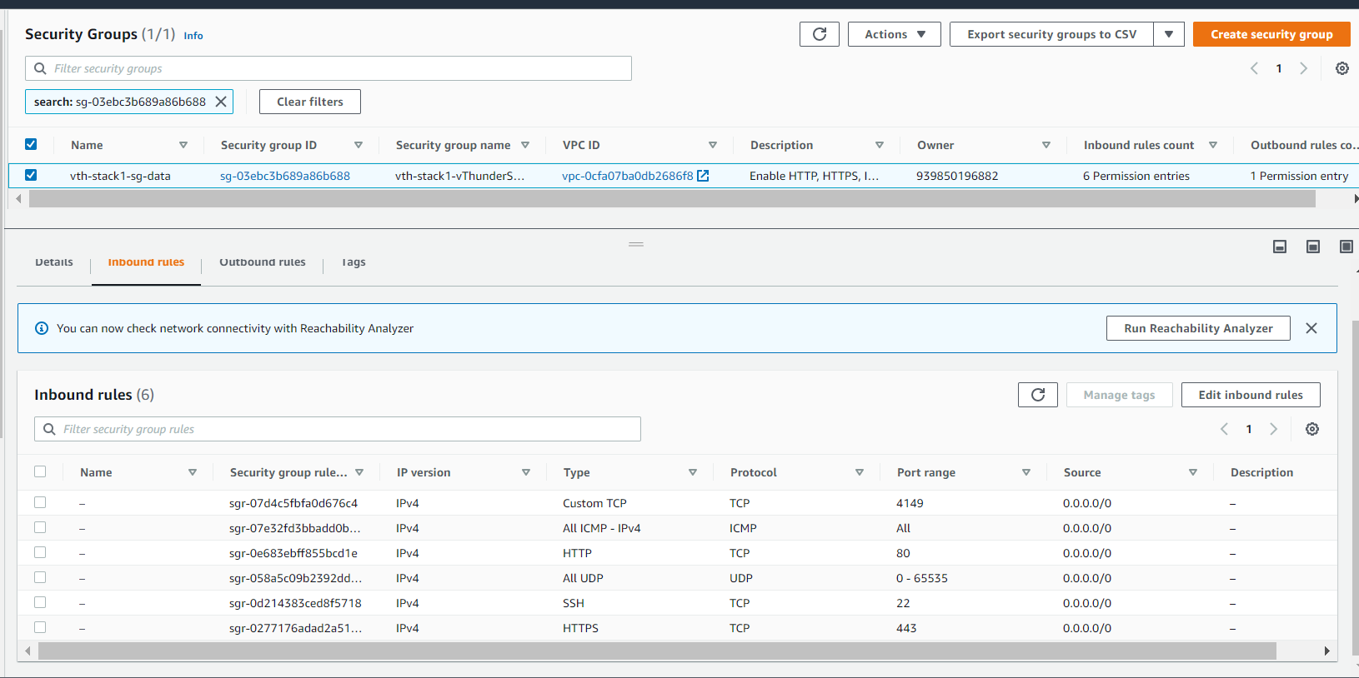

Region 2

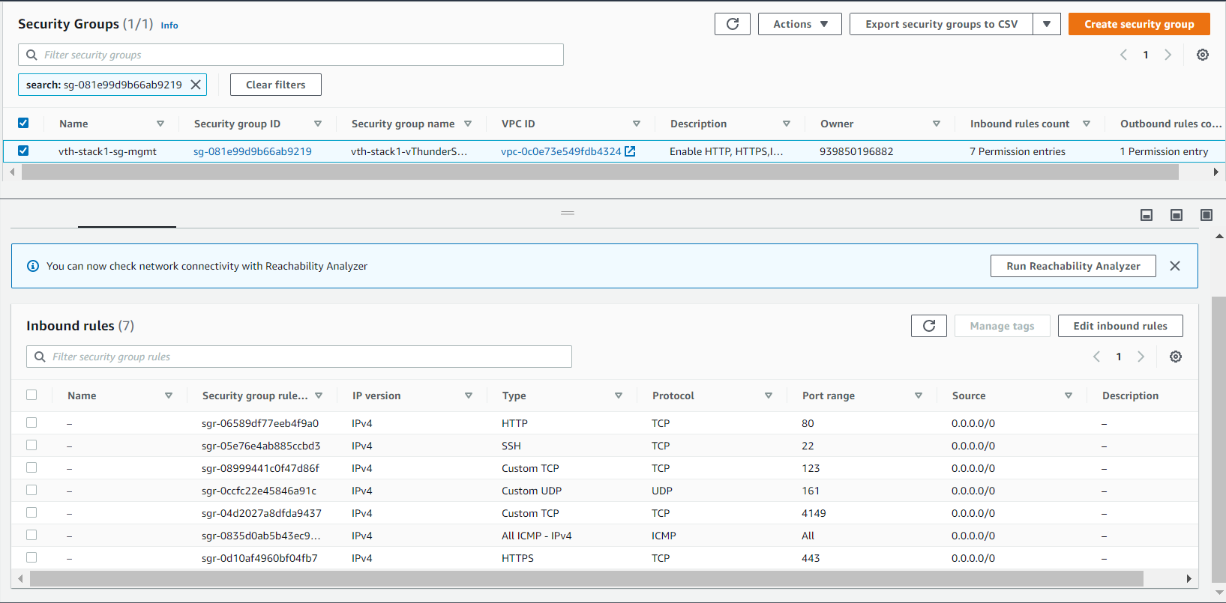

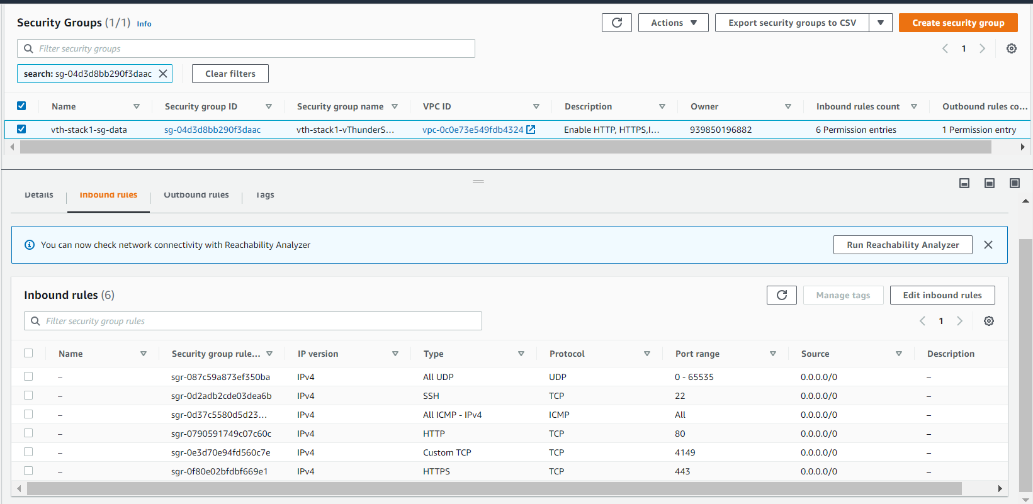

Network Security Group Outbound rules.

Region 1

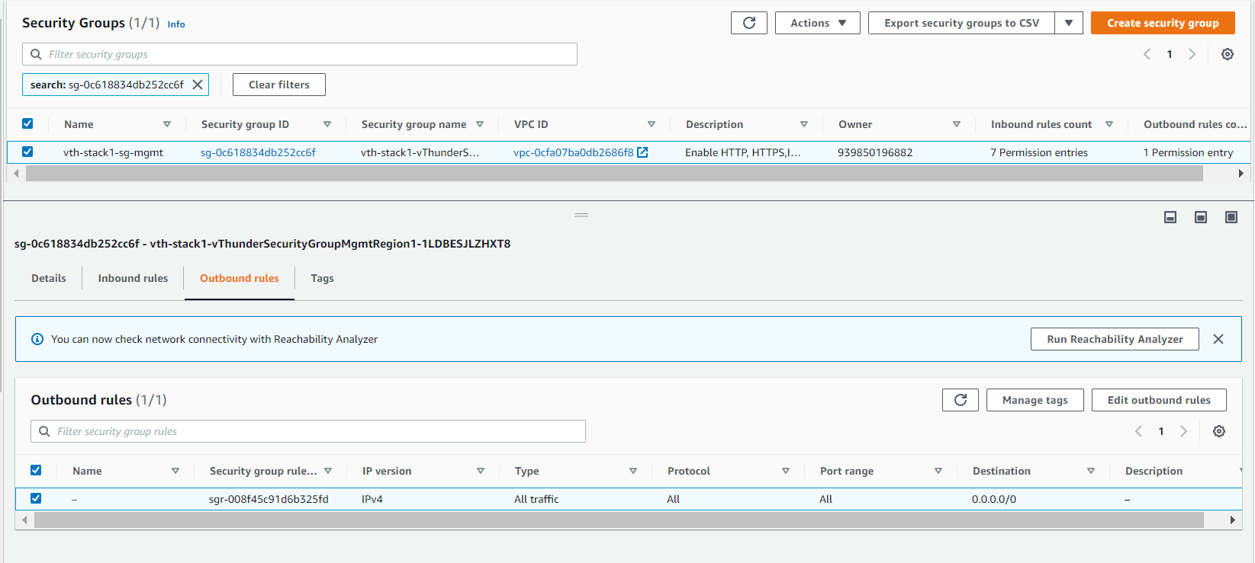

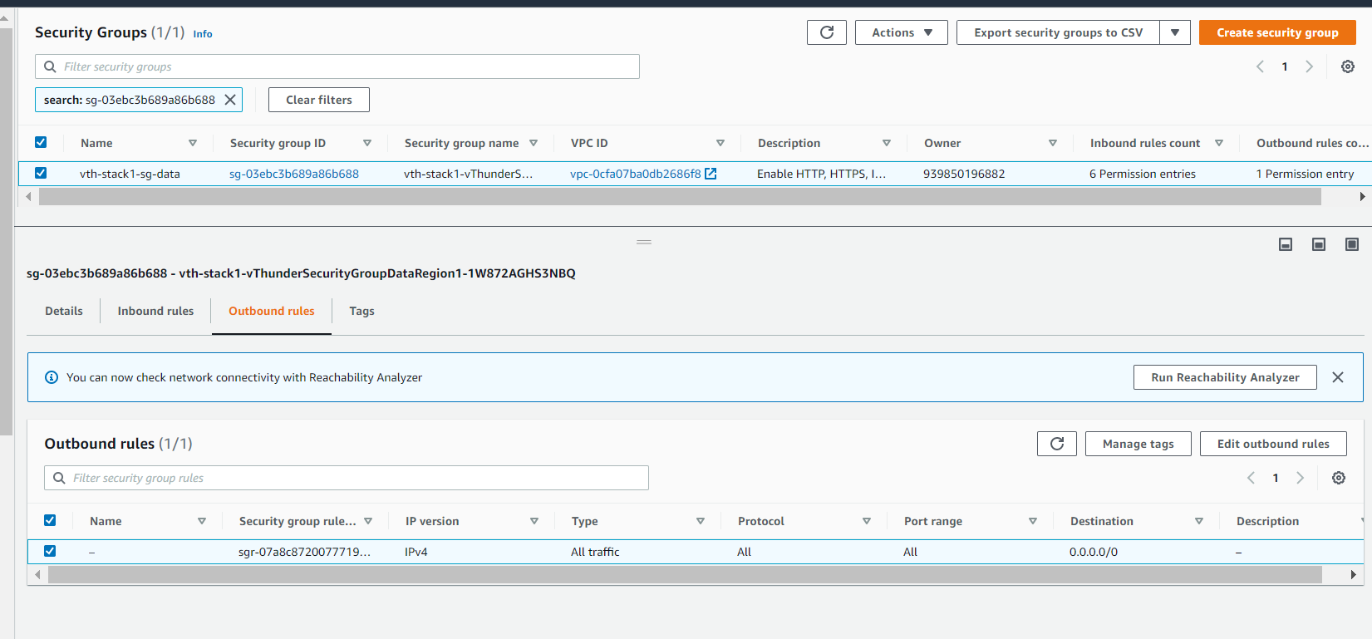

Region 2

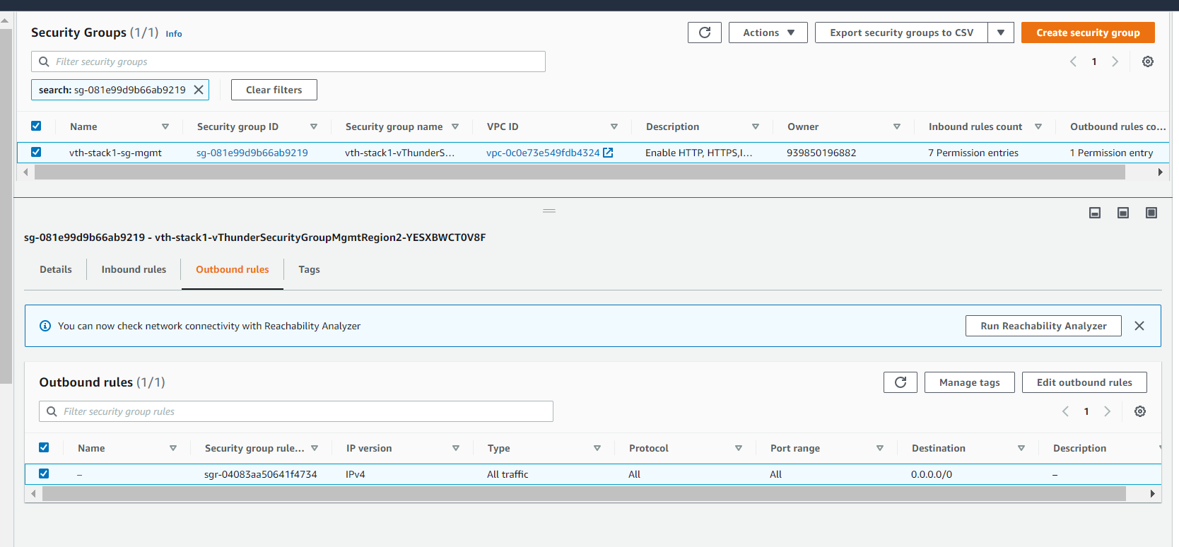

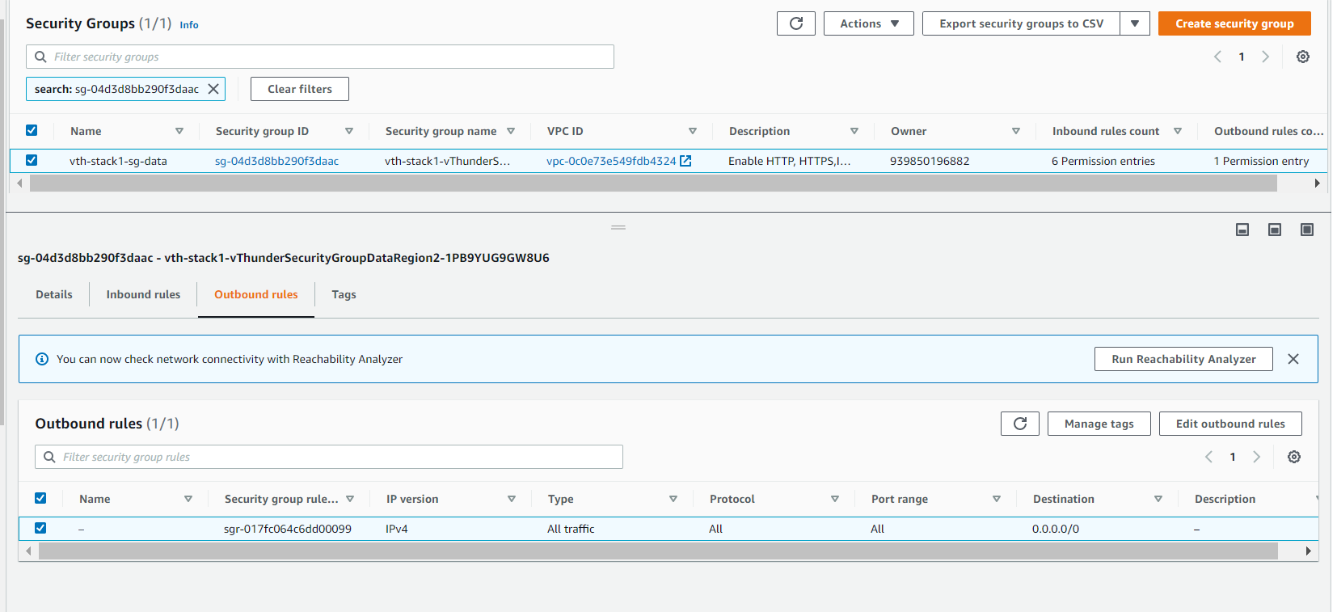

## vThunder Instances

* Expected Outcome: 3 vThunder instances should get created (two site and one controller) in each region.
* Actual Outcome: 3 vThunder instances are created (two site and one controller) in each region.

Region 1

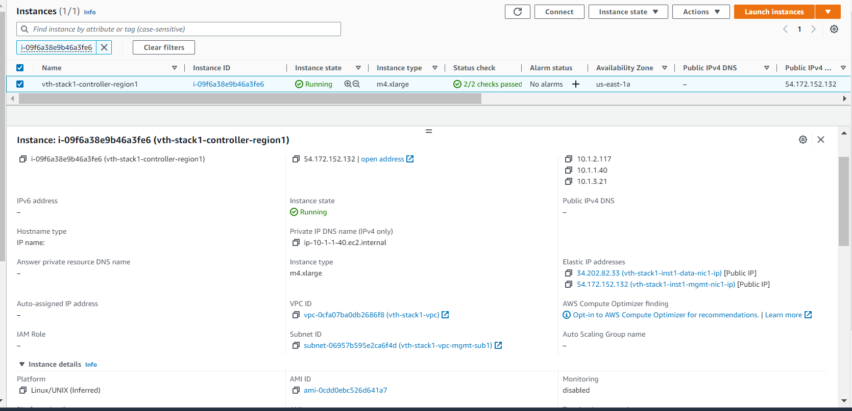

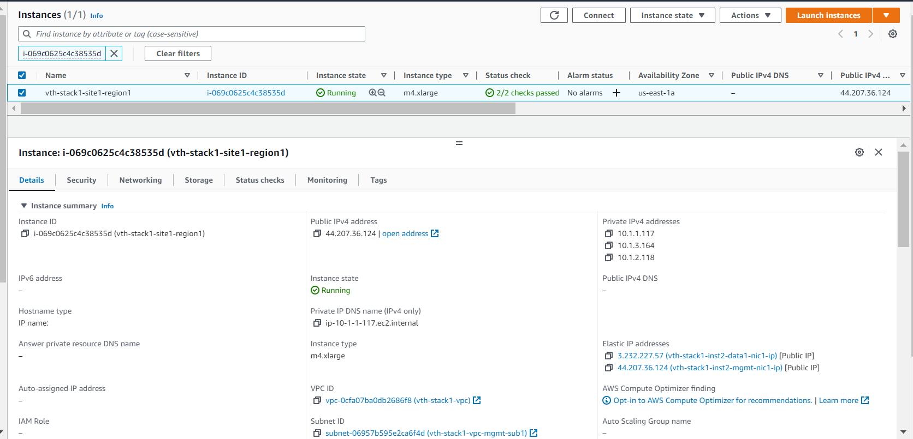

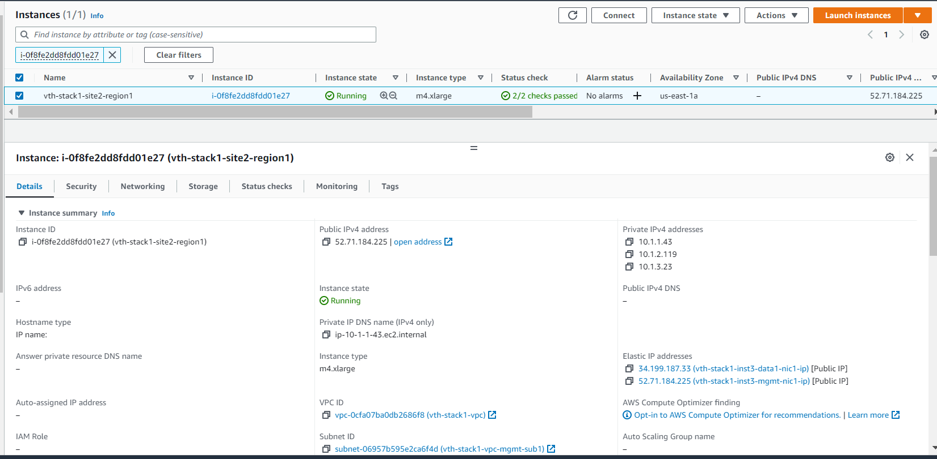

Region 2

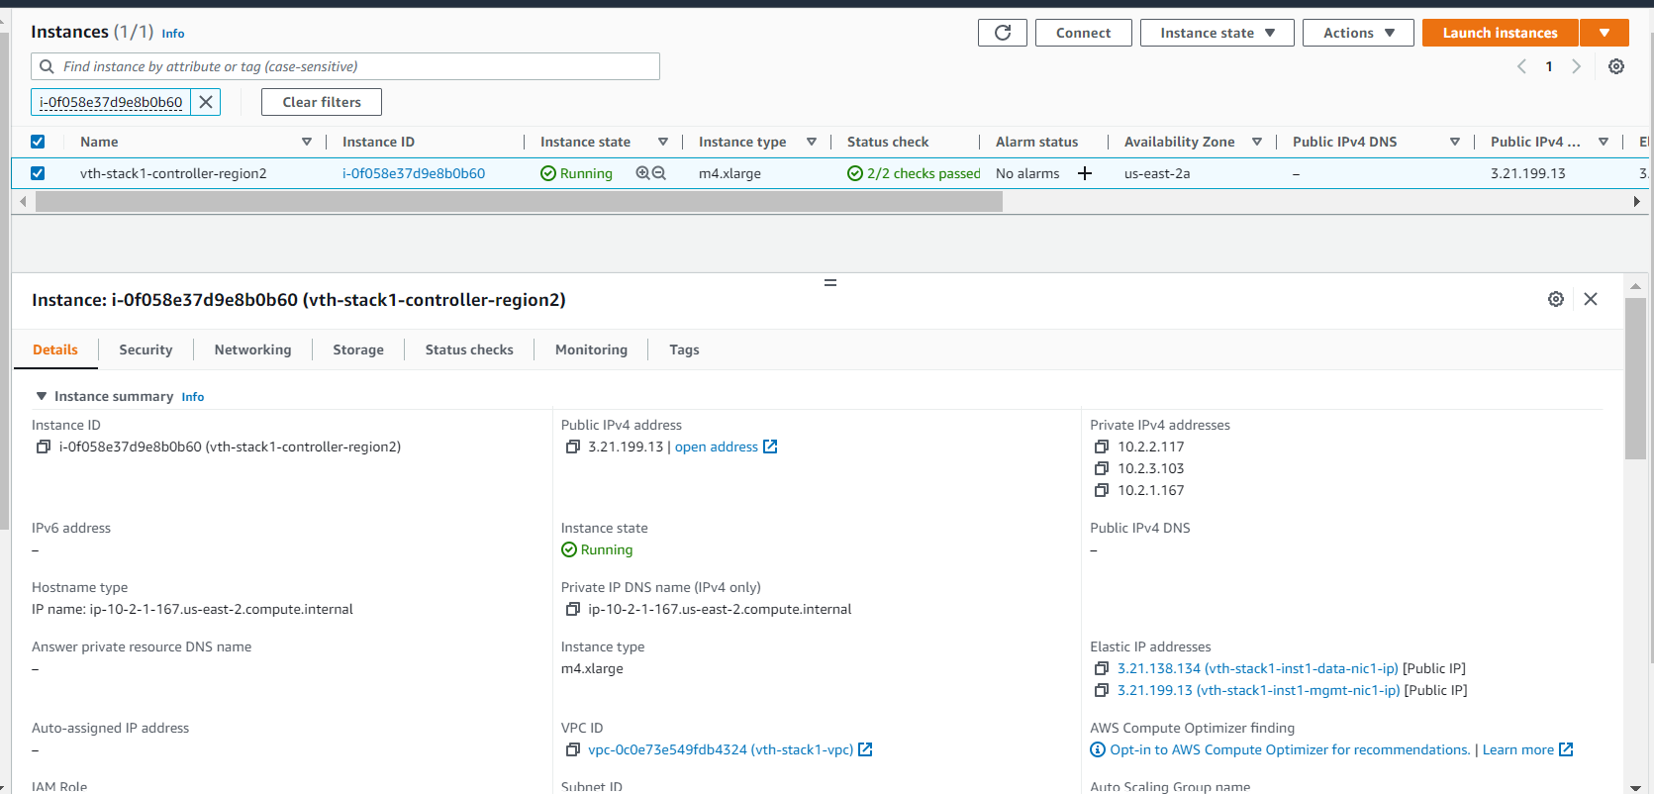

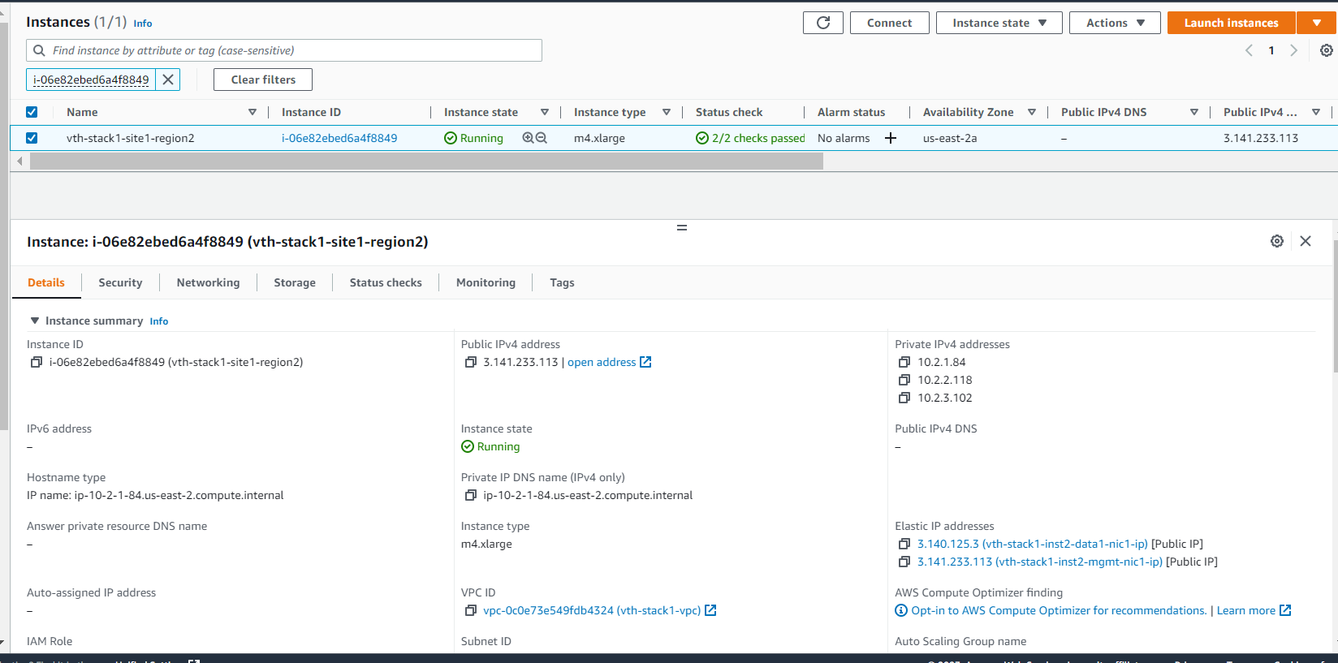

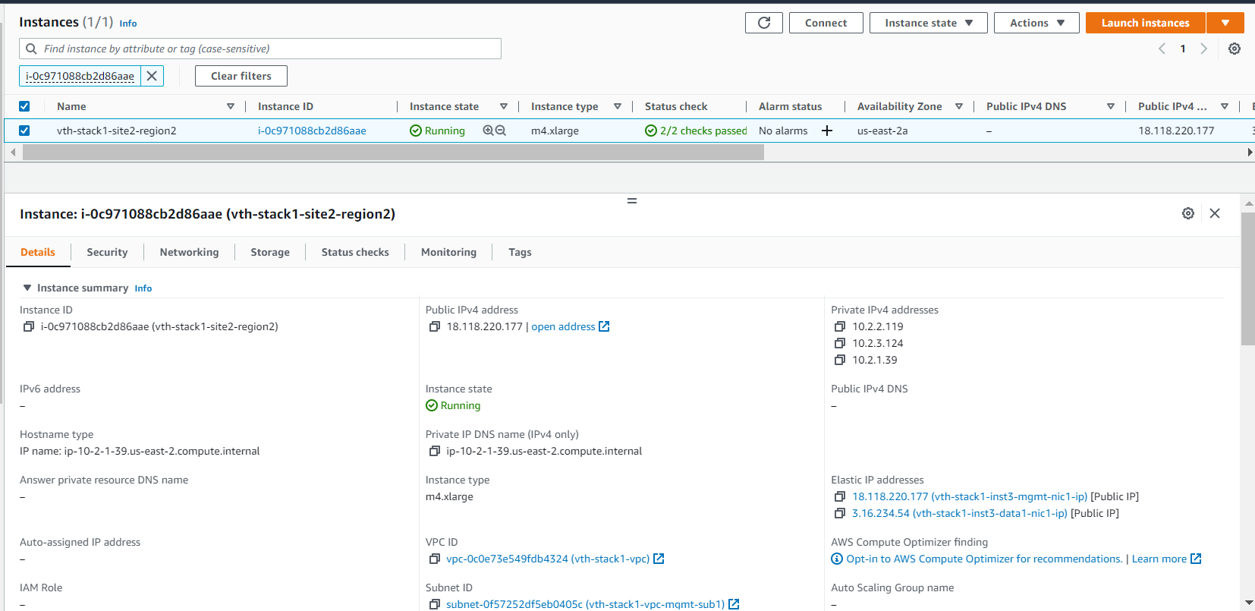

## Server Instances

* Expected Outcome: 2 ubuntu server instances should get in each region.
* Actual Outcome: 2 ubuntu server instances get in each region

Region1

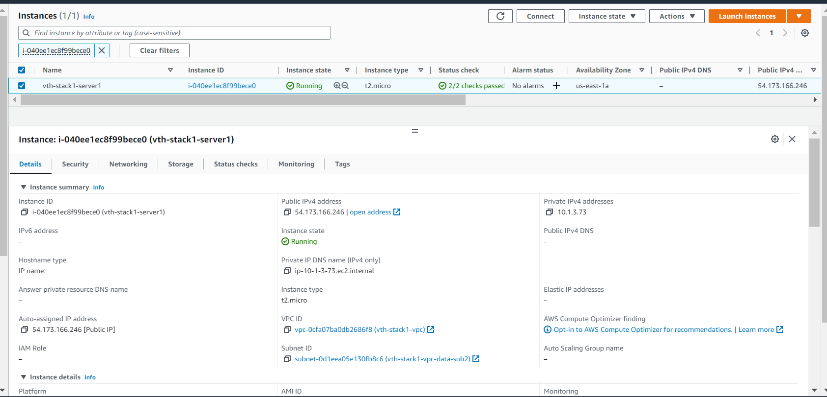

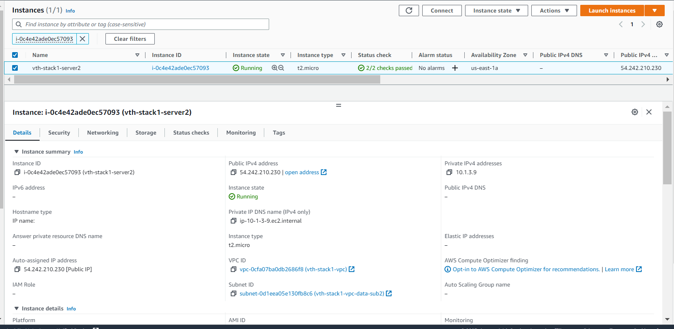

Region2

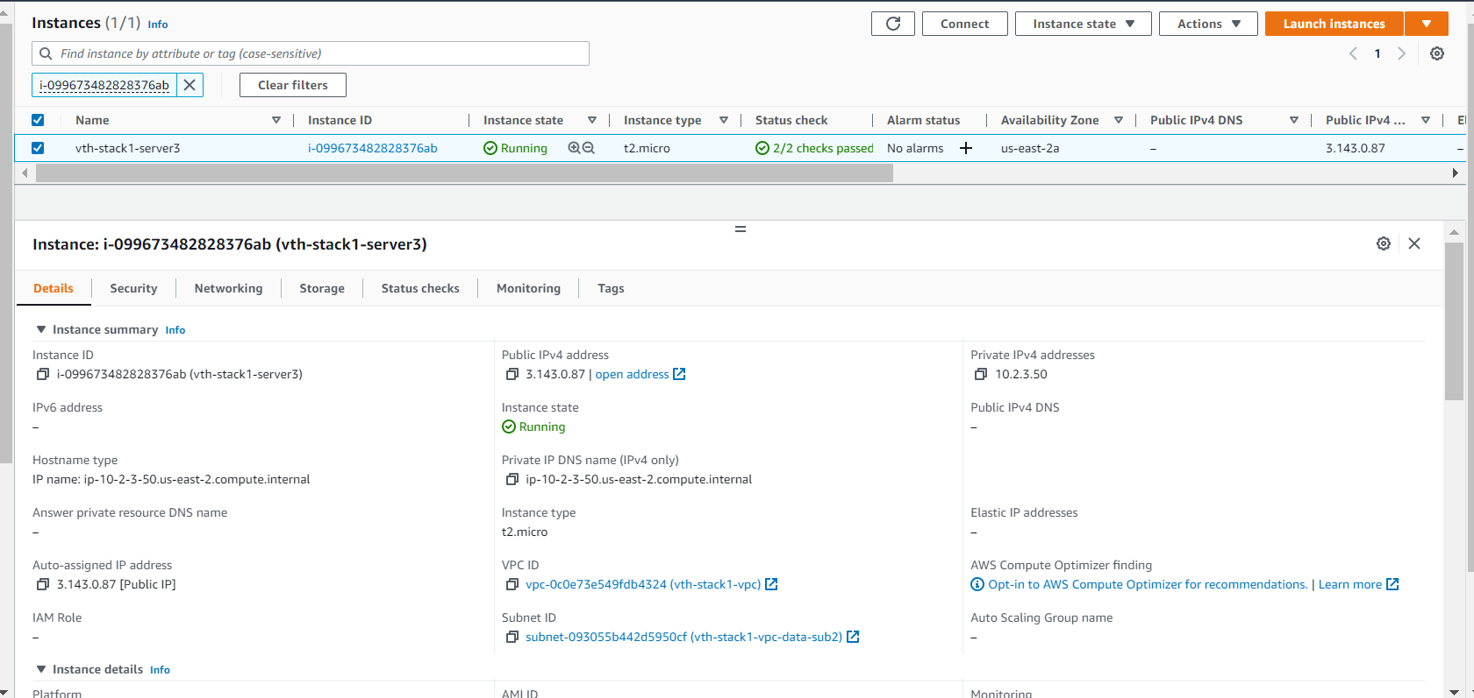

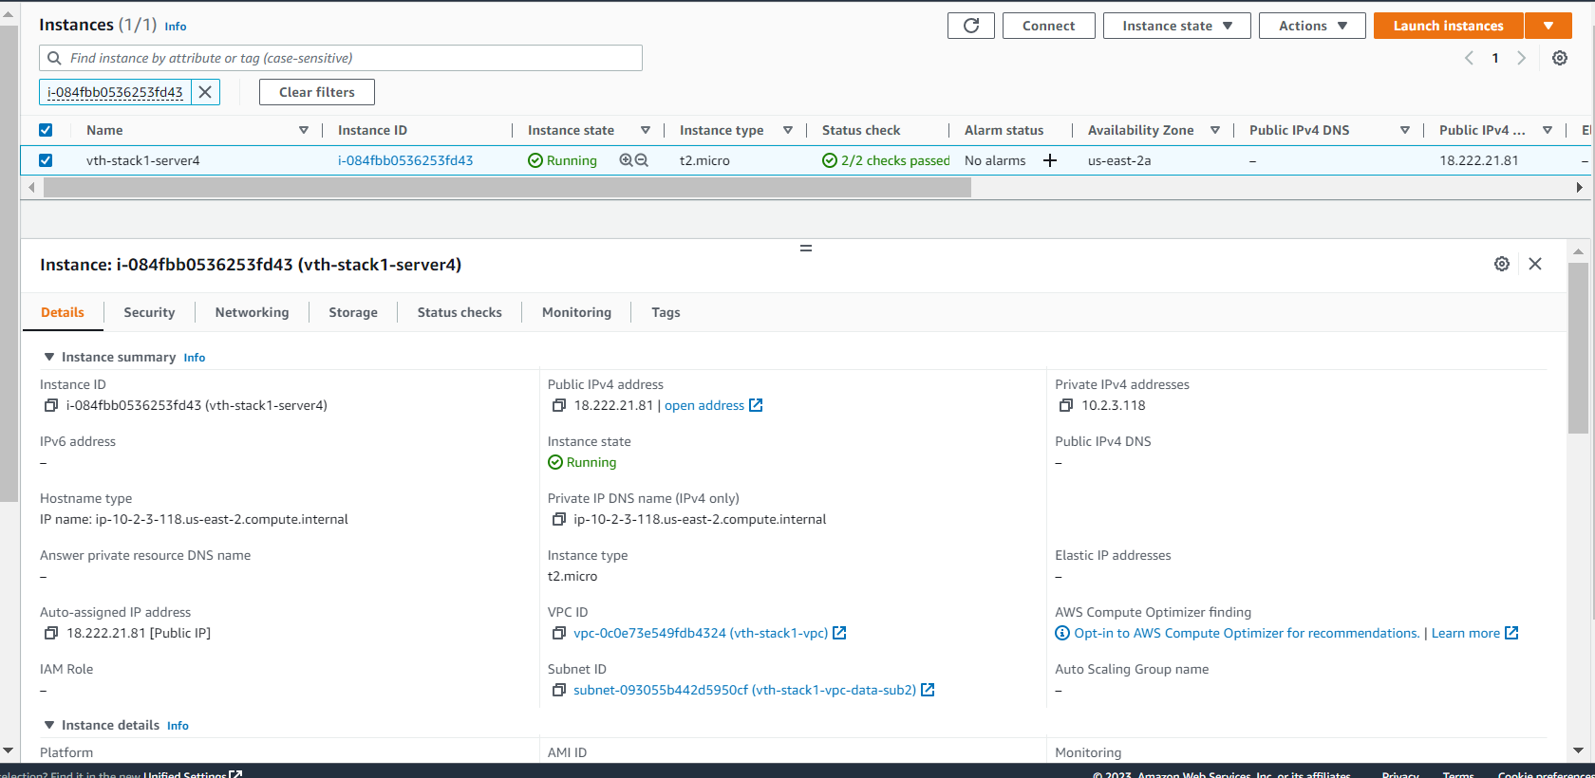

# vThunder Networking Configuration on AWS

## vThunder-1[controller side]

### Management Interface

* Expected Outcome: Management interface should get created in each region.
* Actual Outcome: Management interface gets created in each region.

Region 1

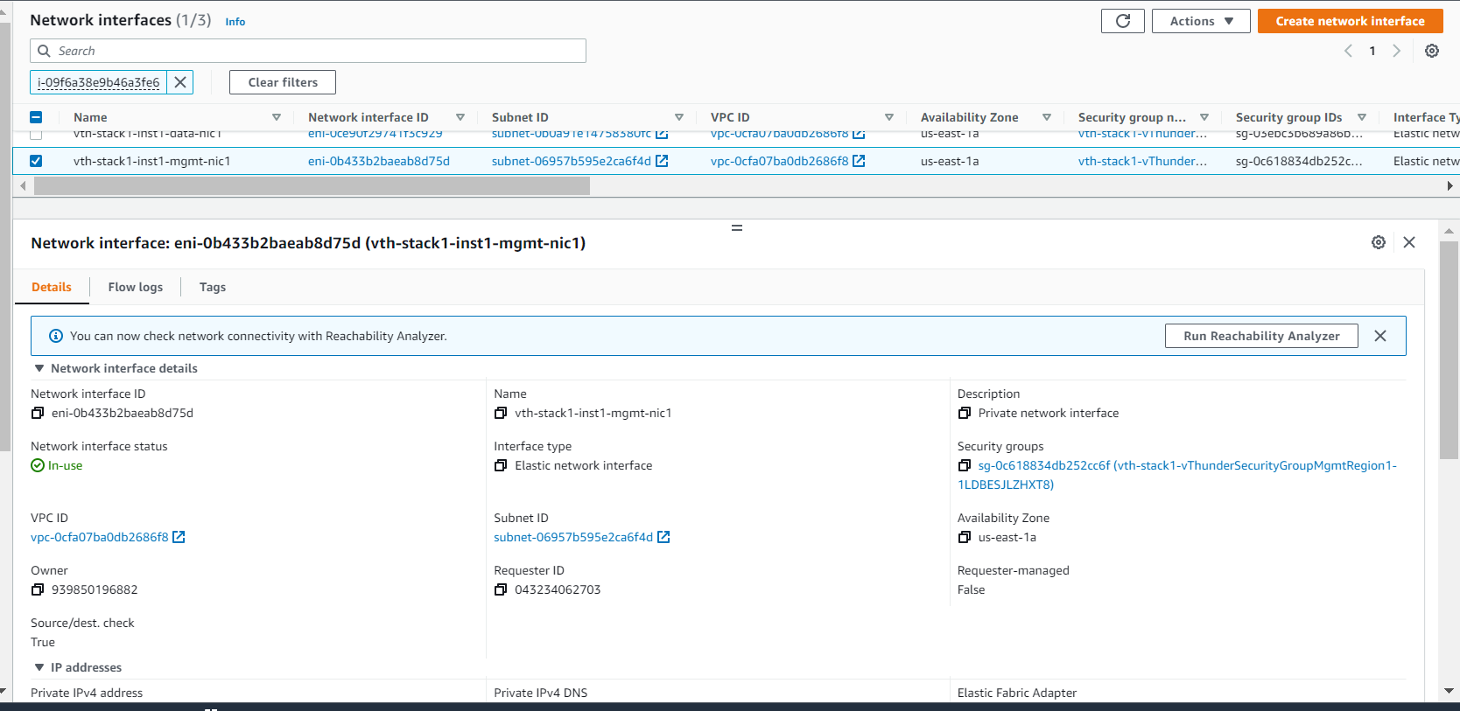

Region 2

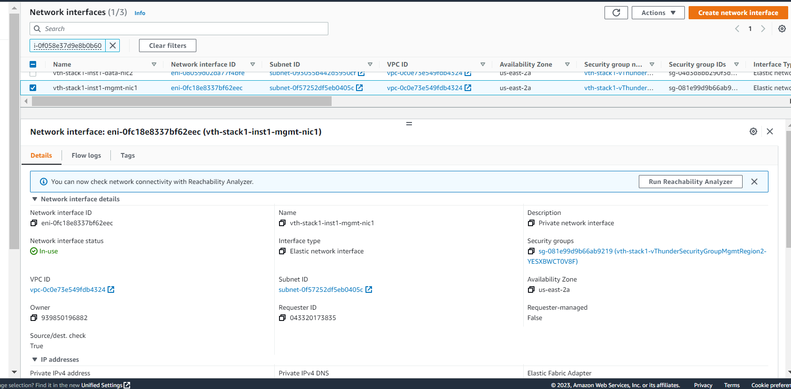

### Data Interface (Client Side)

* Expected Outcome: Client side data interface should get created in each region
* Actual Outcome: Client side data interface has 1 primary ip and 1 private secondary ip.

Region 1

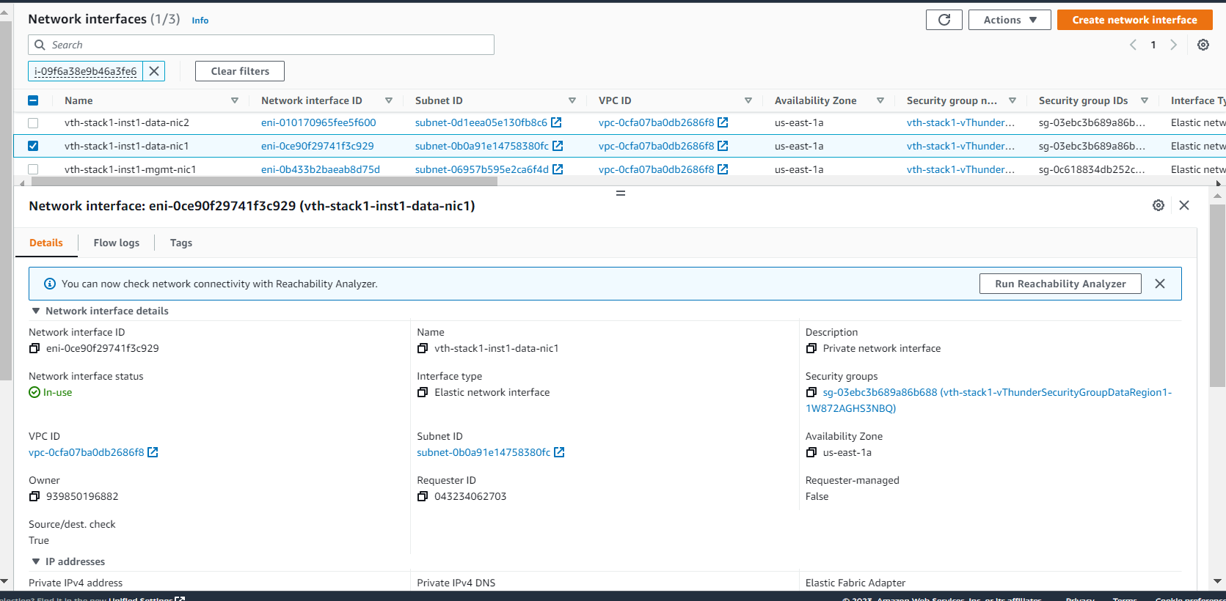

Region 2

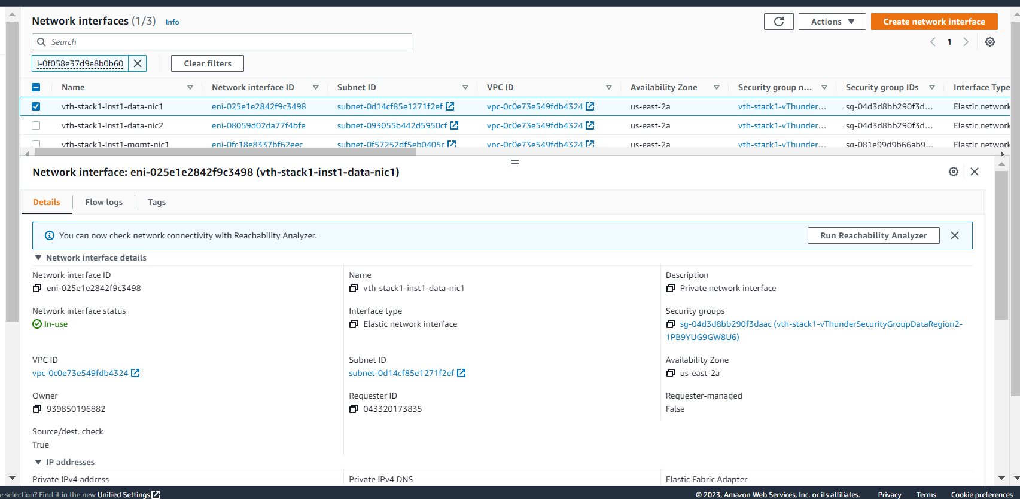

### Data Interface (Server Side)

* Expected Outcome: Server side interface should get created in each region
* Actual Outcome: Server side interface gets created in each region.

Region 1

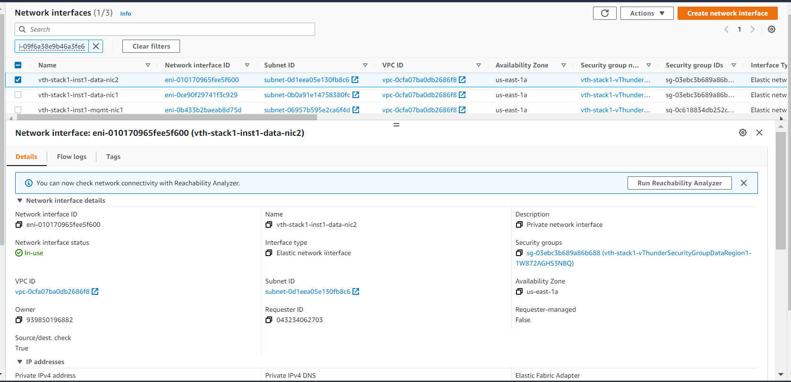

Region 2

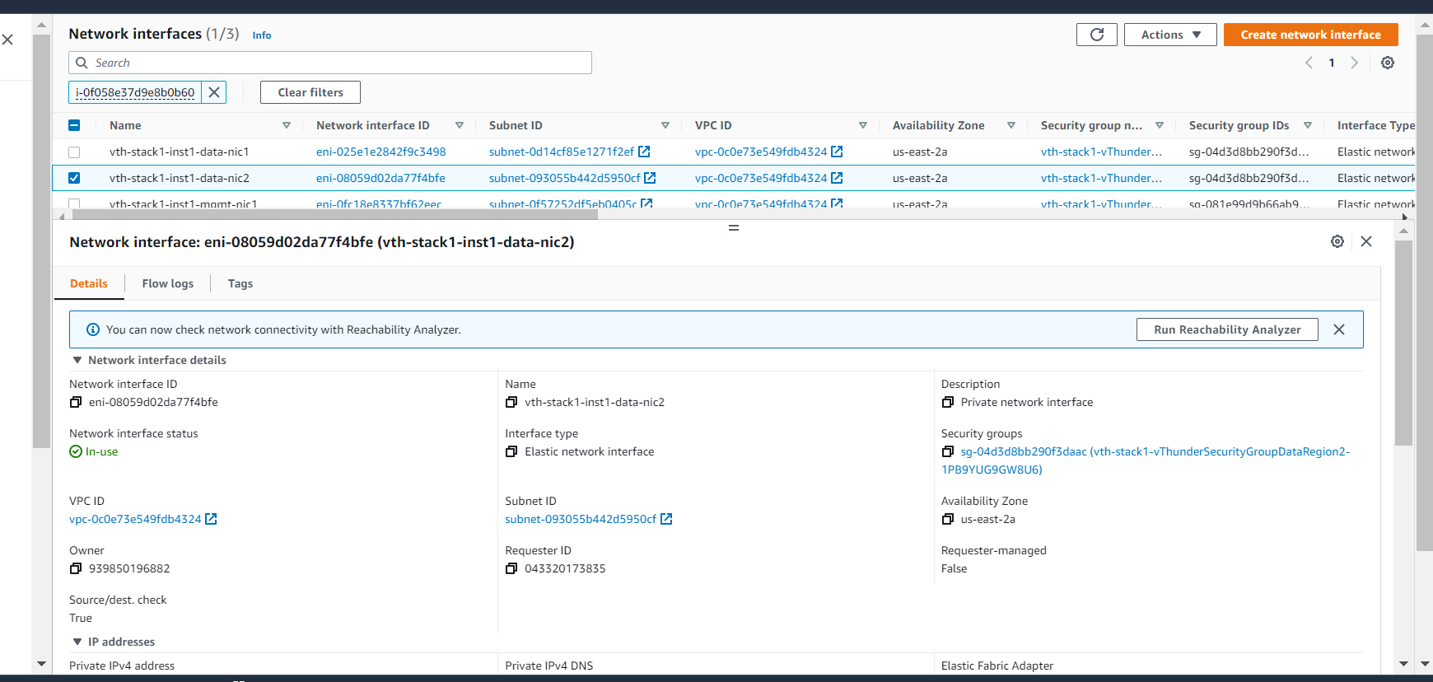

## vThunder-2[site 2]

### Management Interface

* Expected Outcome: Management interface should get created in each region
* Actual Outcome: Management interface gets created in each region

Region 1

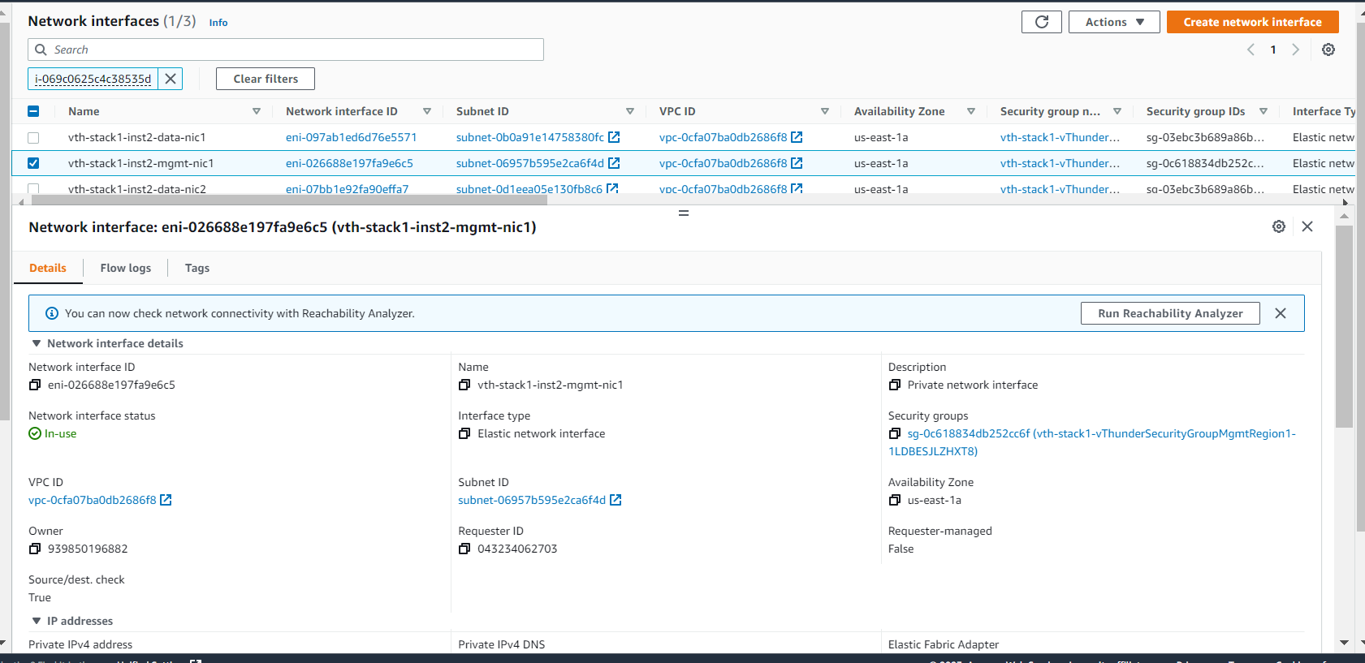

Region 2

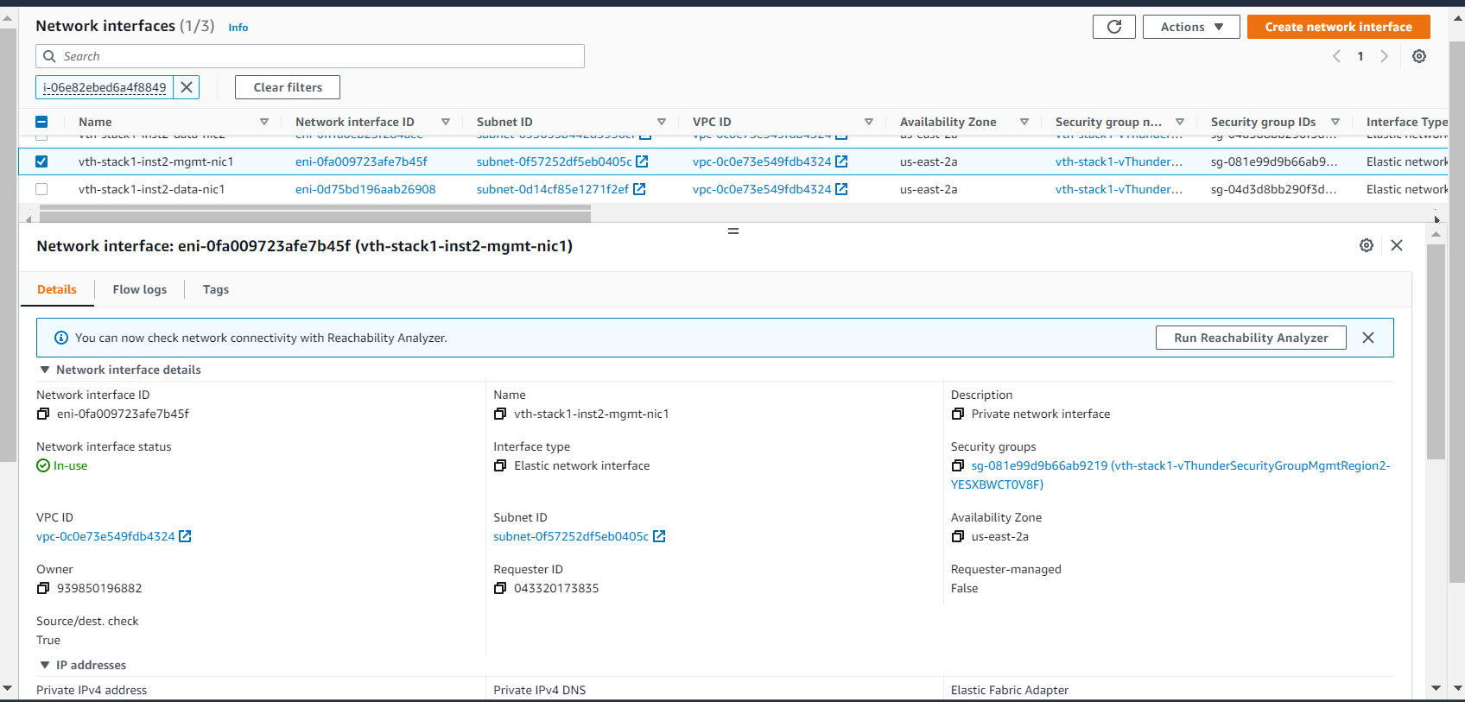

### Data Interface (Client Side)

* Expected Outcome: Client side data interface should get created in each region
* Actual Outcome: Client side data interface gets created in each region

Region 1

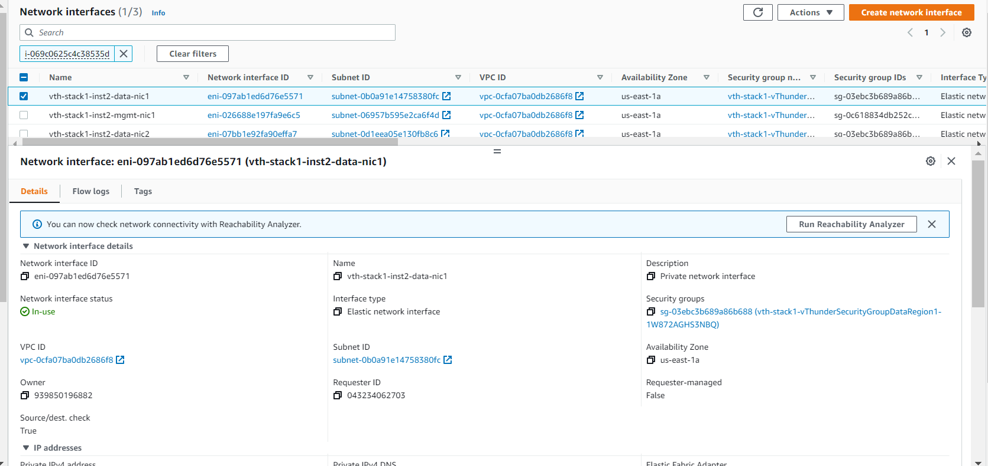

Region 2

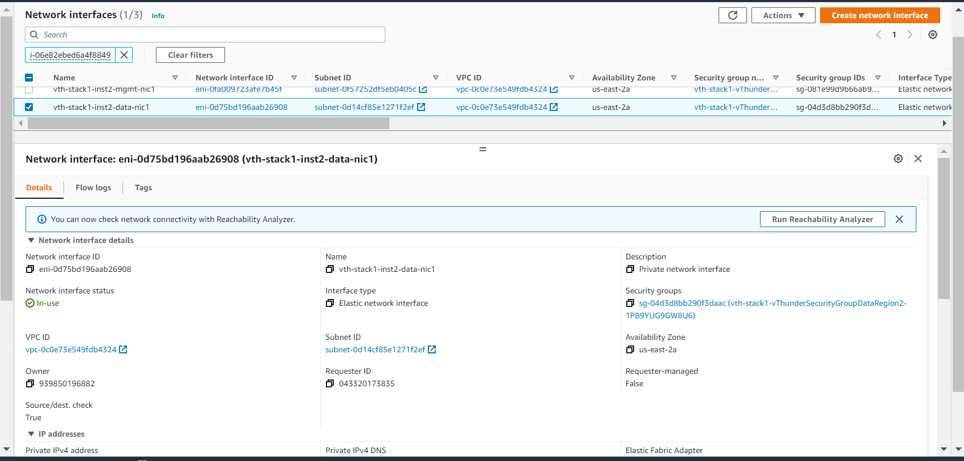

### Data Interface (Server Side)

* Expected Outcome: Server side interface should get created in each region.
* Actual Outcome: Server side interface gets created in each region.

Region 1

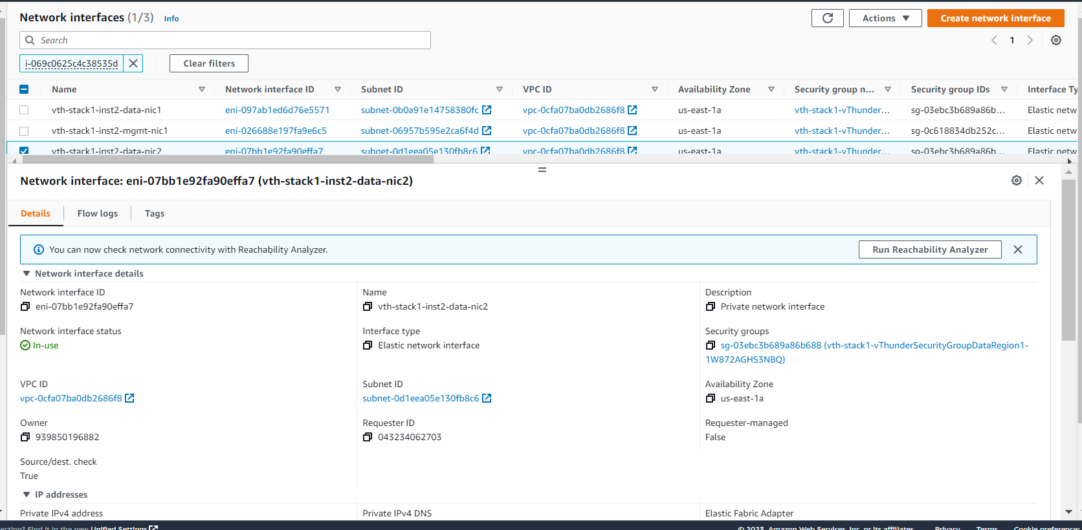

Region 2

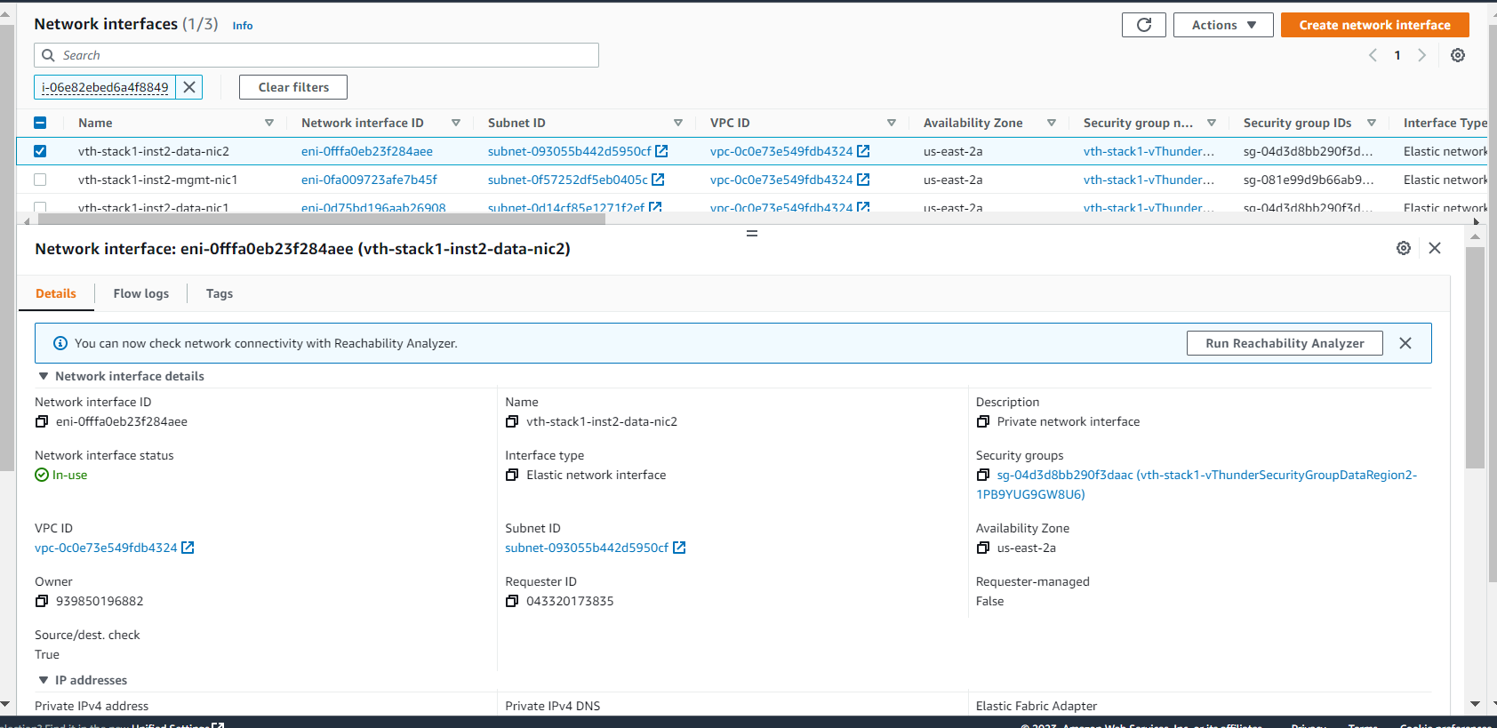

## vThunder-3[SITE 2]

### Management Interface

* Expected Outcome: Management interface should get created in each region
* Actual Outcome: Management interface gets created in each region.

Region 1

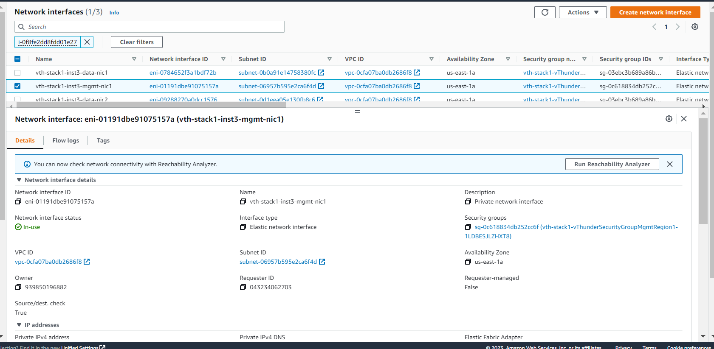

Region 2

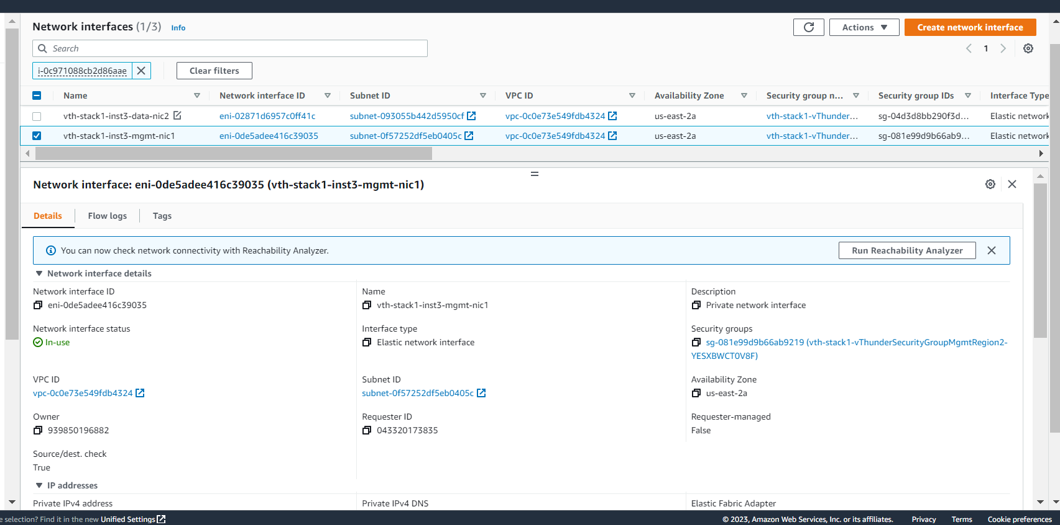

### Data Interface (Client Side)

* Expected Outcome: Client side data interface should get created in each region.
* Actual Outcome: Client side data interface gets created in each region

Region 1

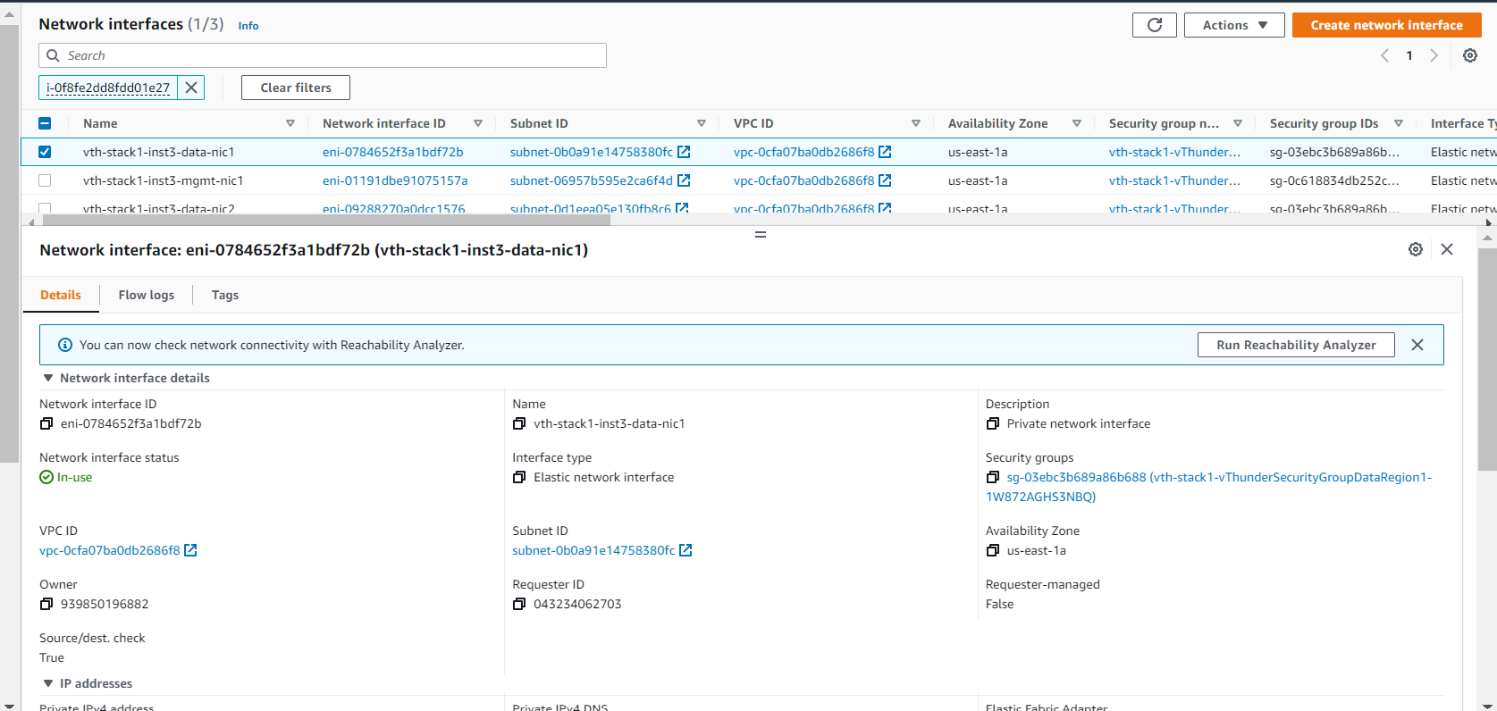

Region 2

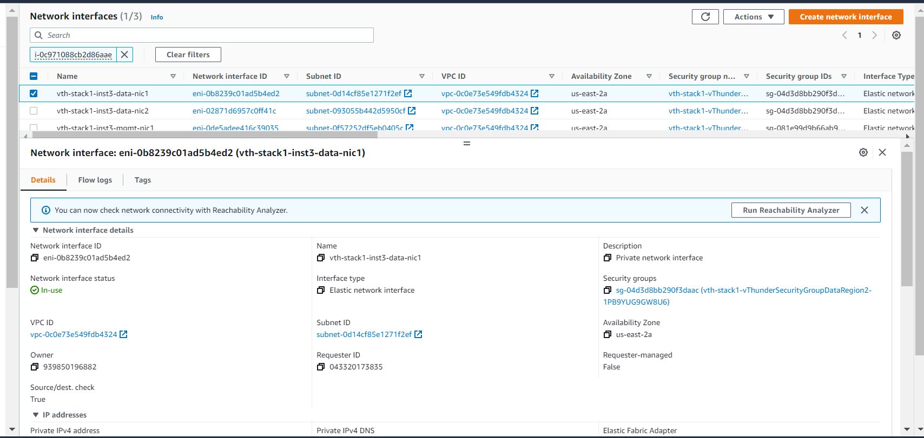

### Data Interface (Server Side)

* Expected Outcome: Server side interface should get created in each region
* Actual Outcome: Server side interface gets created in each region.

Region 1

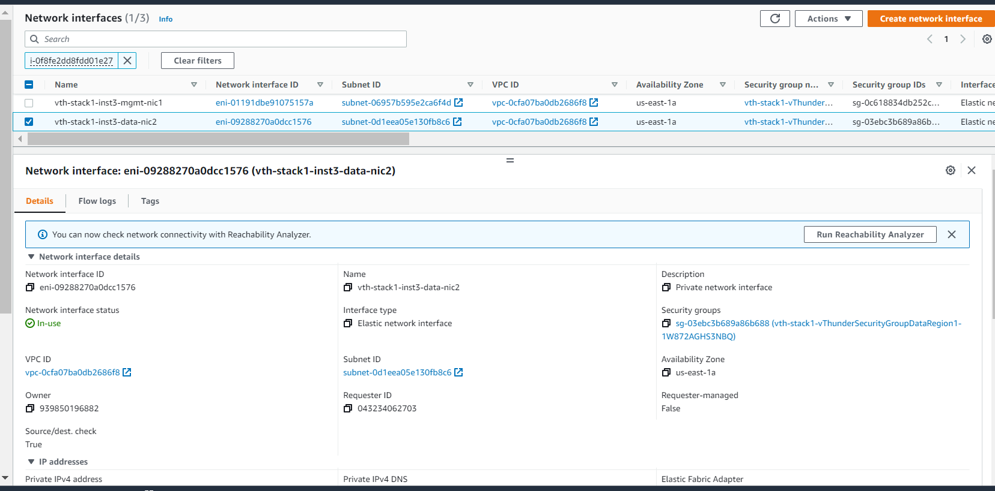

Region 2

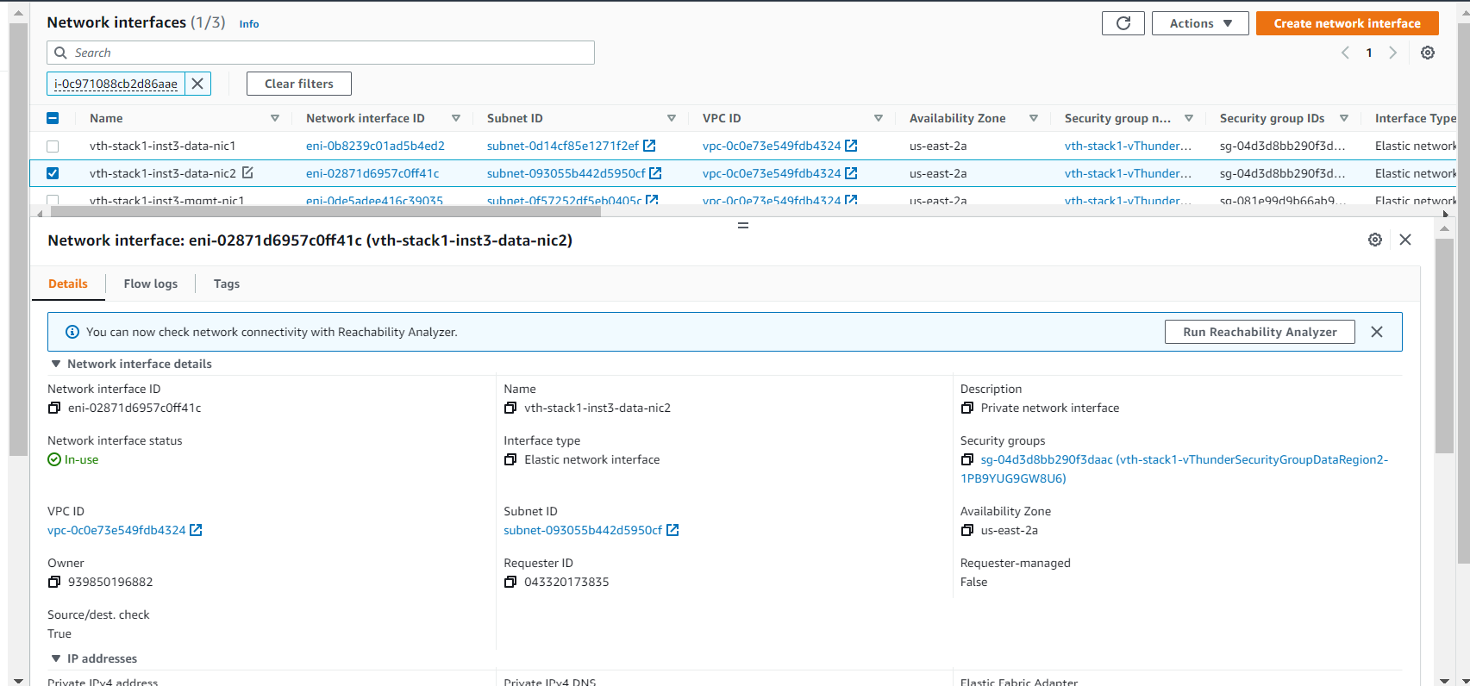

# vThunder IP Configuration

### GSLB Group

1. {stack name} -controller-region1

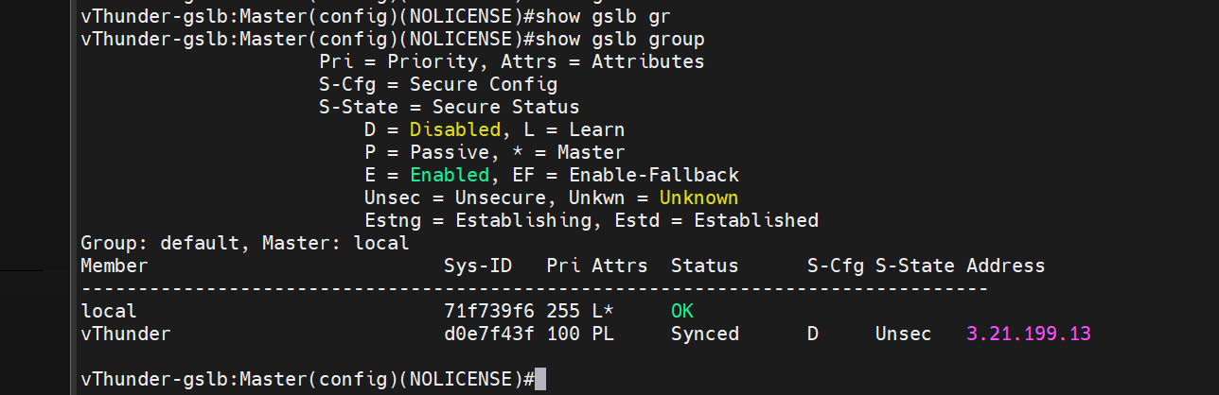

1. {stack name} -controller-region2

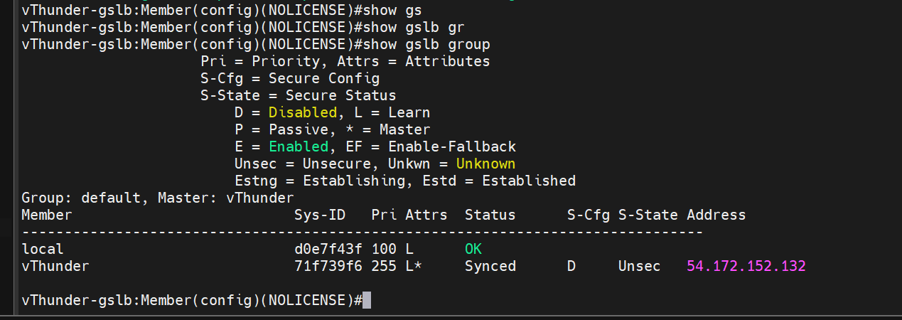

### GSLB Protocol

1. vth-controller-region1

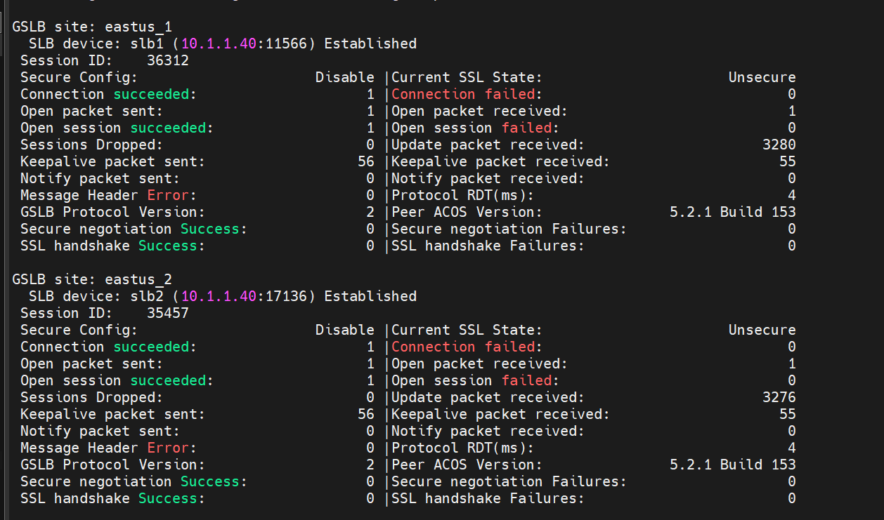

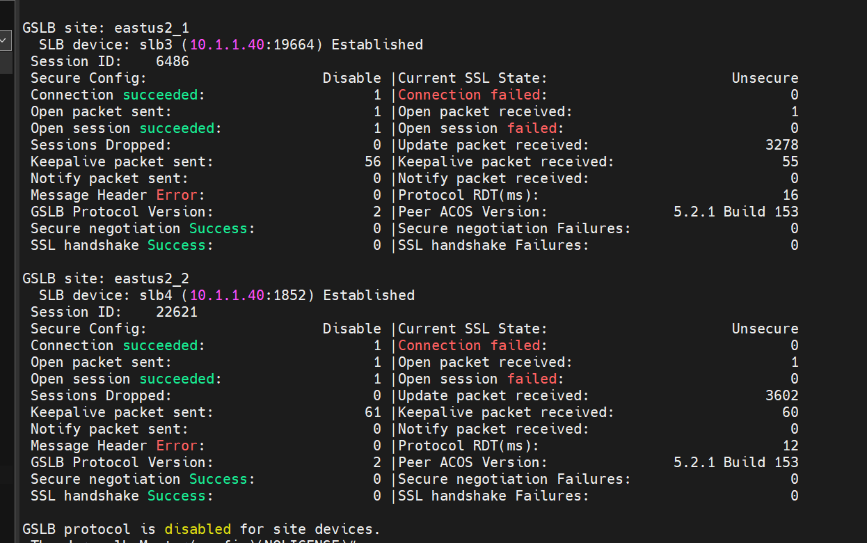

1. vth-controller-region2

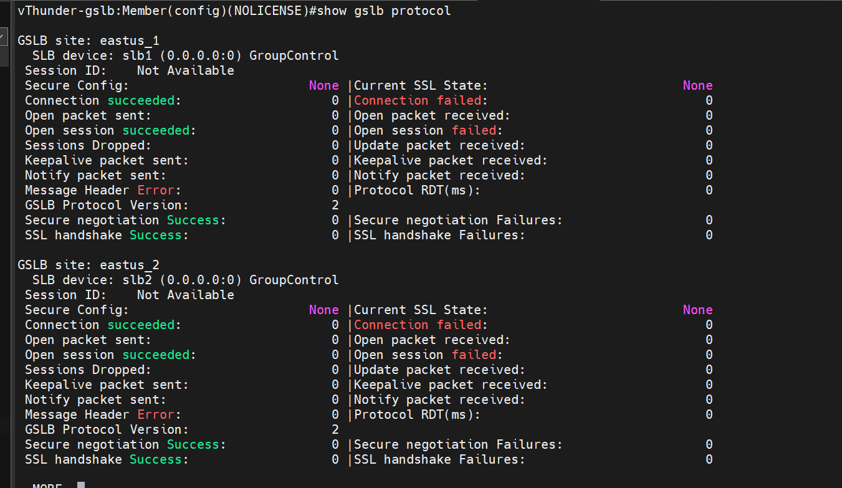

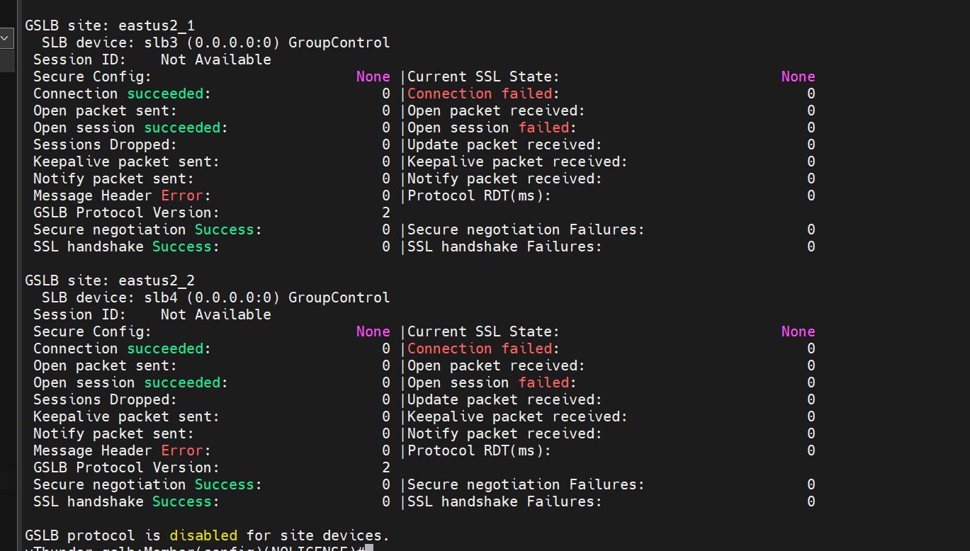

### Sites and Controller Complete Configurations:

1. CONTROLLER – region1 CONFIG:

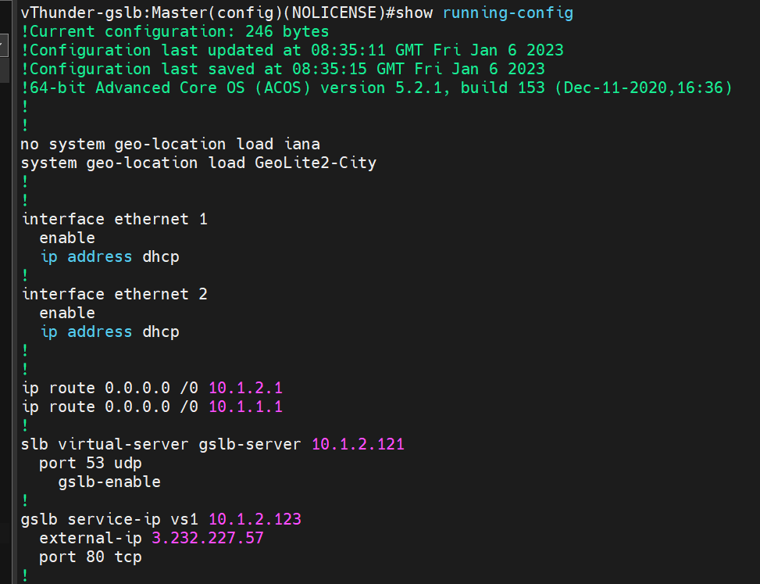

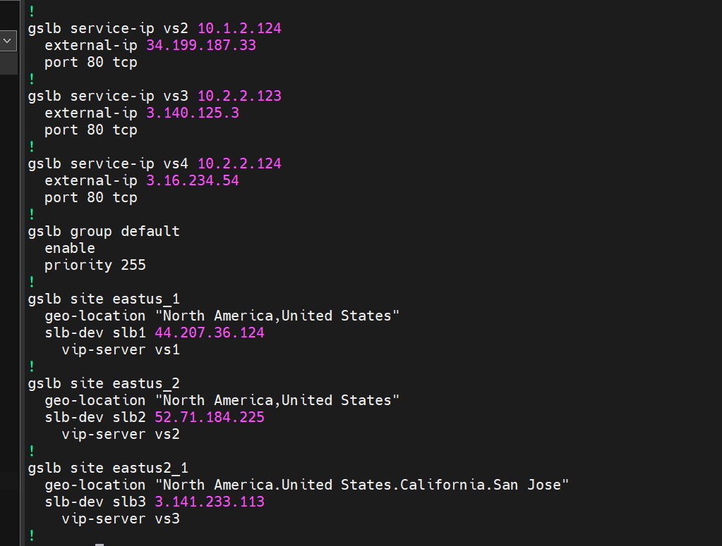

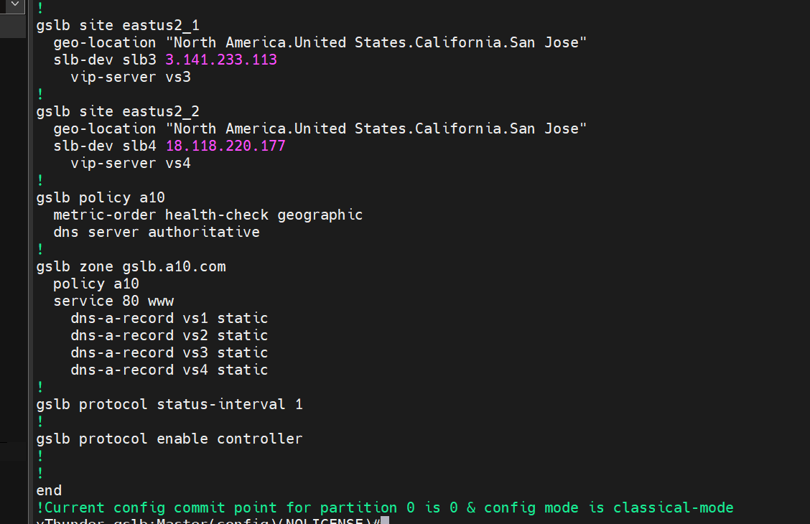

1. CONTROLLER -region2 CONFIG:

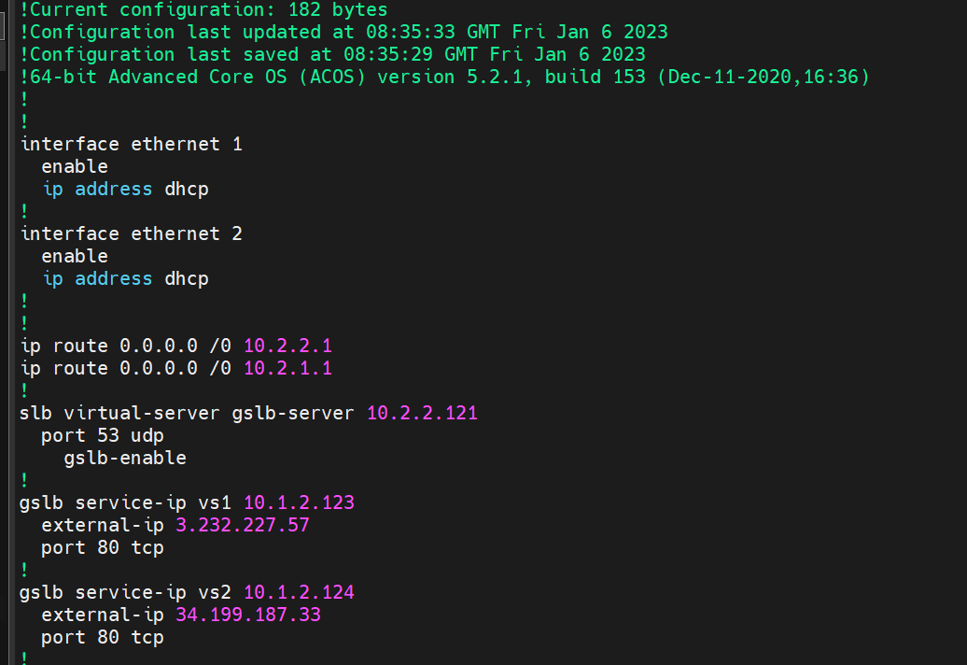

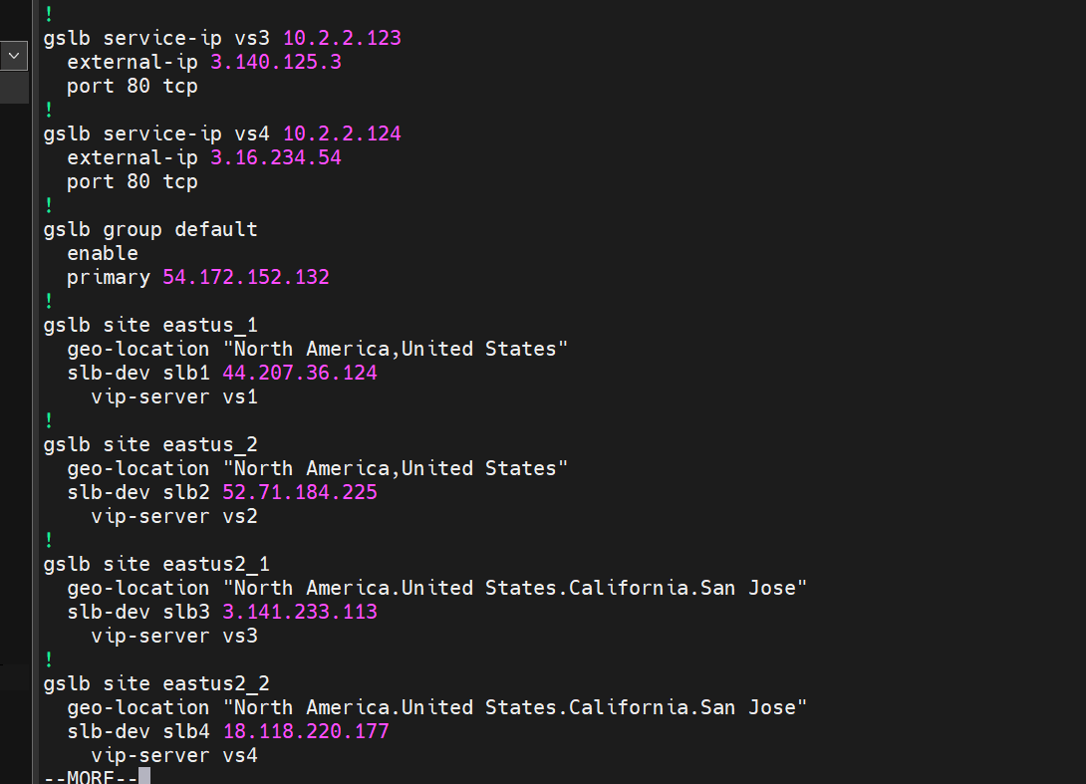

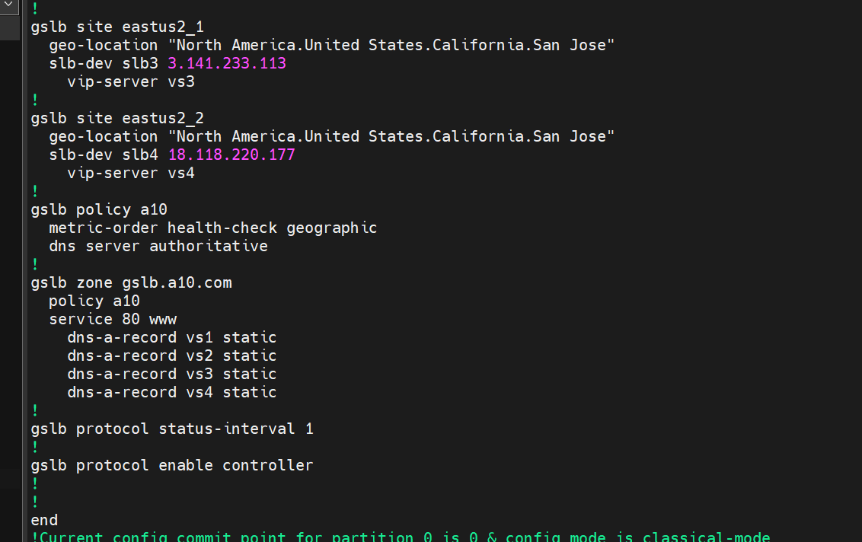

1. SITE 1(region1) configuration:

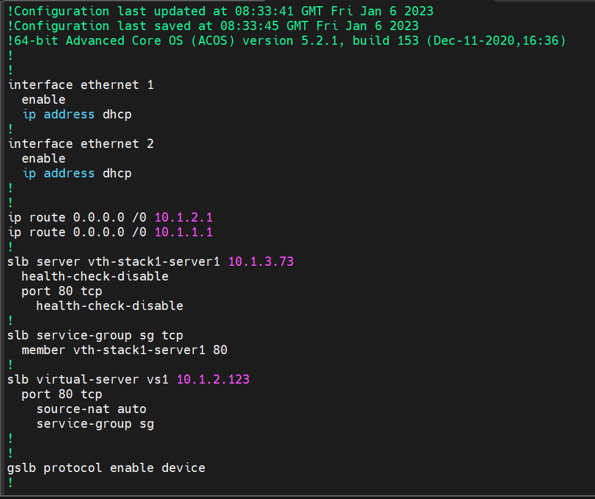

1. SITE 2(region1) configuration:

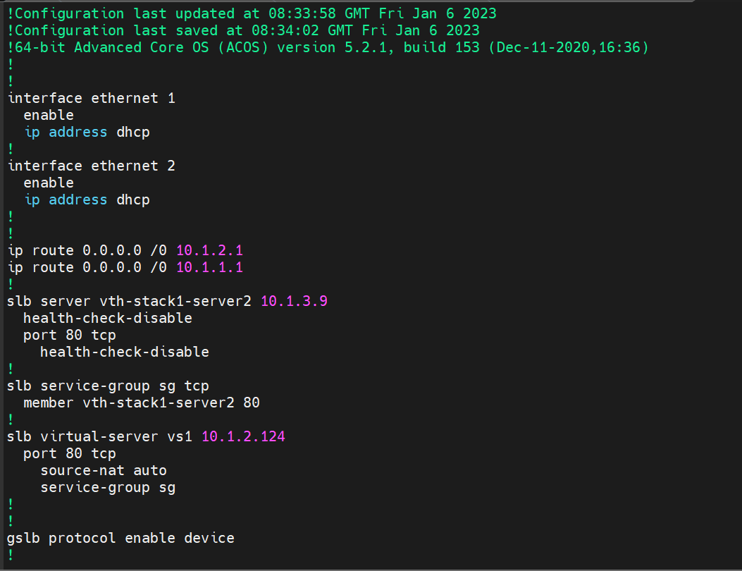

1. SITE 1(region2) configuration:

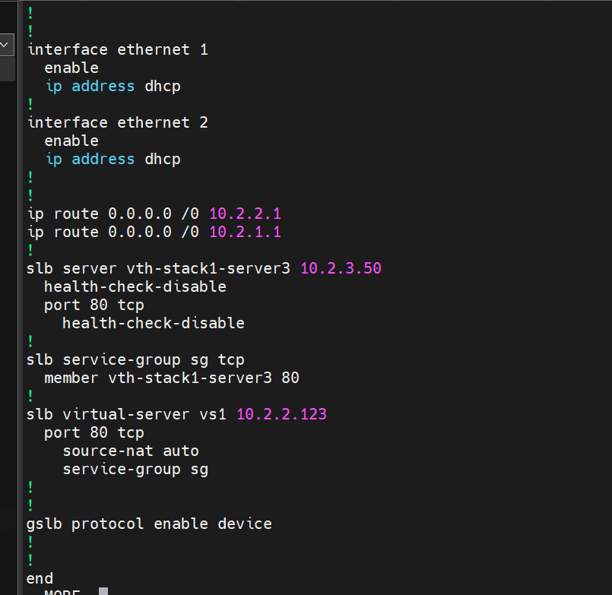

1. SITE 2(region2) configuration:

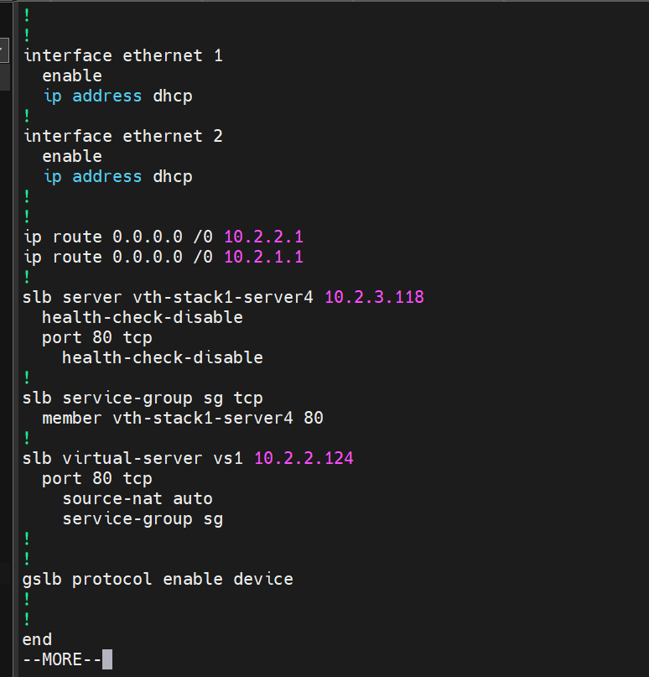

### DNS lookup

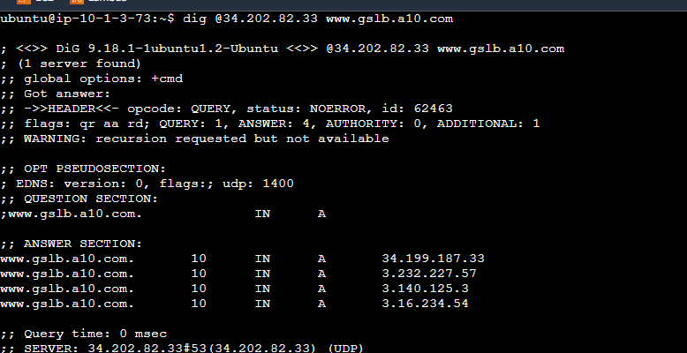

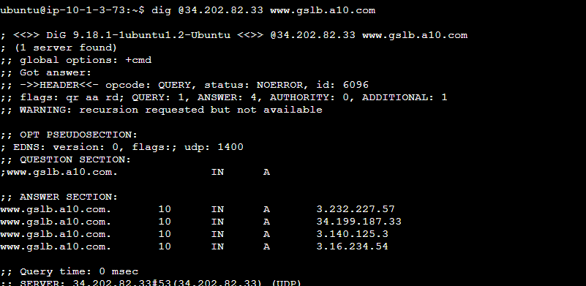

stopping the site instances of region1 and then running the dig command again.

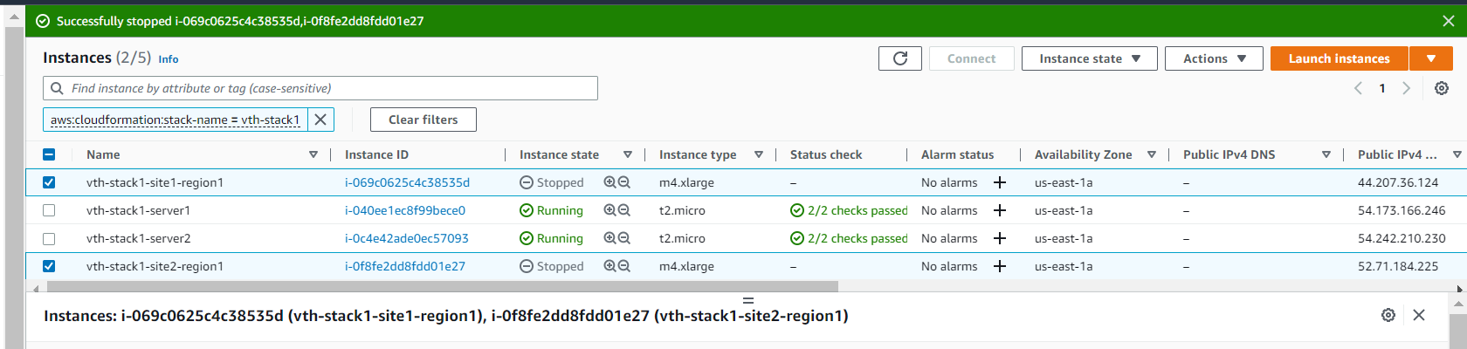

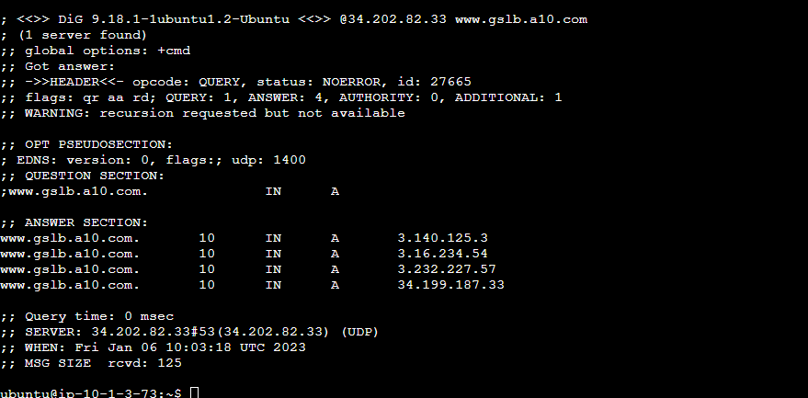

### WGET

